LOGISTICS MANAGEMENT SYSTEM WITH CLIENT FEEDBACK MECHANISM

Table 1
Black-box Testing of the Alpha Testing of Registration and Authentication Case
Test Case ID | Description | Expected Outcome | Actual Outcome | Pass/ Fail | Comments
TC-01 | Admin / Owner Login with Valid Credentials | The system verifies the Admin/Owner credentials, creates an authenticated session, and redirects the user to the Admin Portal with access to authorized modules. | Valid Admin/Owner credentials were accepted, and the user was successfully authenticated and redirected to the Admin Portal. | Pass | Login successful
TC-02 | Role-Based Redirection for Warehouse Staff, Driver, and Client Portals | The system verifies the user's assigned role and redirects the user to the corresponding Warehouse Staff, Driver, or Client Portal with authorized features. | The system successfully redirected the Warehouse Staff, Driver, and Client to their corresponding portals based on their assigned roles. | Pass | Role-based access worked correctly
TC-03 | Login Failure with Invalid Credentials or Unregistered Account | The system rejects the login attempt, displays the “Invalid email or password” error message, and does not create an authenticated session. | The system rejected the invalid or unregistered credentials, displayed an error message, and did not allow access to the system. | Pass | Invalid credentials handled correctly
TC-04 | Client Registration Submission and OTP / Confirmation Generation | The system validates the registration details, creates a pending client account, generates and sends an OTP, and displays the OTP verification screen. | Valid registration details were accepted, and the system proceeded to generate and send the OTP for account verification. | Pass | Registration and OTP generated successfully
TC-05 | Client Account Activation via Valid OTP Confirmation Code | The system validates the OTP within the allowed verification period, activates the client account, displays a successful verification message, and grants access to the Client Portal. | The valid OTP was accepted and verified successfully, allowing the client account to be activated. | Pass | OTP verified successfully
TC-06 | Client Registration Failure on Expired or Incorrect OTP Code | The system rejects an incorrect or expired OTP, keeps the account unverified, displays the appropriate error message, and allows the user to request a new OTP. | The incorrect OTP was rejected, the appropriate error message was displayed, and the account remained unverified. | Pass | Invalid OTP handled correctly
TC-07 | Owner Creates and Manages Staff / Driver Credentials | The system validates the employee information, creates the Staff or Driver account with the assigned role, and allows the employee to log in using the created credentials. | The employee information was accepted, and the system successfully created the account with the assigned role. | Pass | User account created successfully
TC-08 | Credential Validation on Duplicate Email or Weak Password | The system prevents account creation when the email already exists or the password does not meet the required security requirements and displays the corresponding validation message. | The system blocked the user registration and displayed validation messages indicating that the email address is already registered and that the password does not meet the required criteria, including the minimum of 8 characters. | Pass | Duplicate email and weak password validation worked correctly
TC-09 | Client Self-Service Password Reset via OTP / Email Verification | The system verifies the registered email and OTP, validates and securely updates the new password, and allows the client to log in using the updated credentials. | The system successfully completed the email and OTP verification process and allowed the password to be reset. | Pass | Password reset worked correctly
TC-10 | Owner Force Password Reset / Update for Staff or Driver Account | The system allows the Owner to update the selected Staff or Driver password, securely saves the new credentials, and allows the employee to authenticate using the updated password. | The system opened the Password Reset function for the selected Driver, accepted and saved the new password, and allowed the Driver to log in successfully using the updated credentials. | Pass | Password reset worked correctly

Evidences:
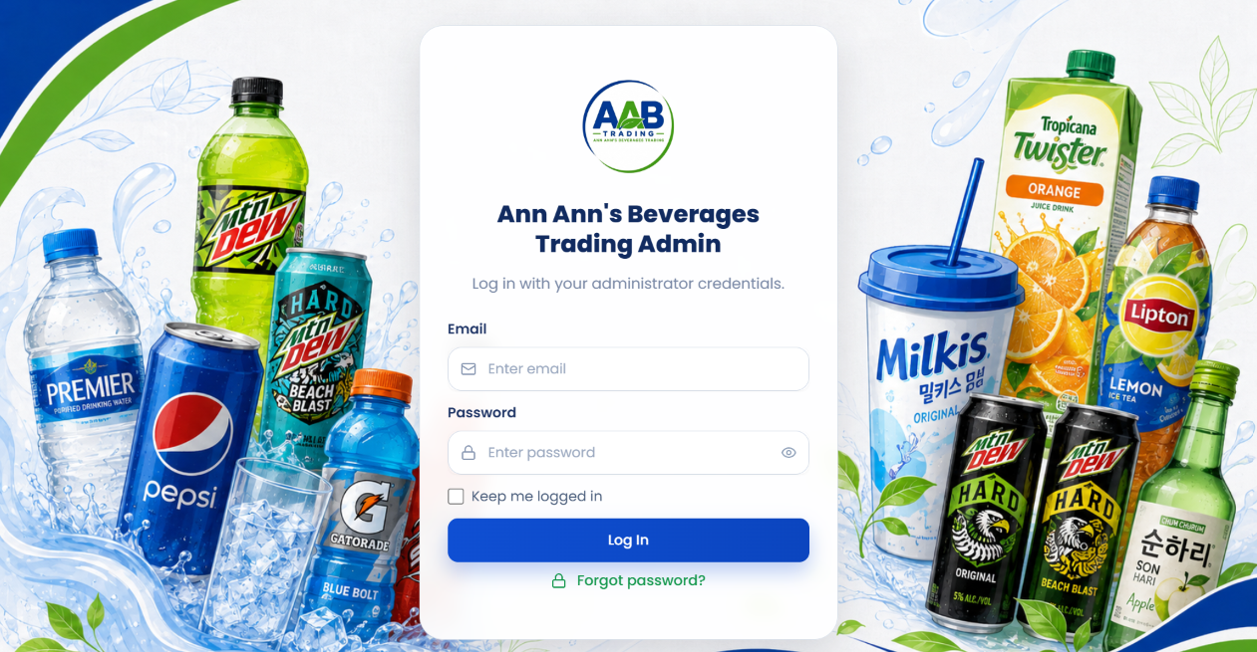
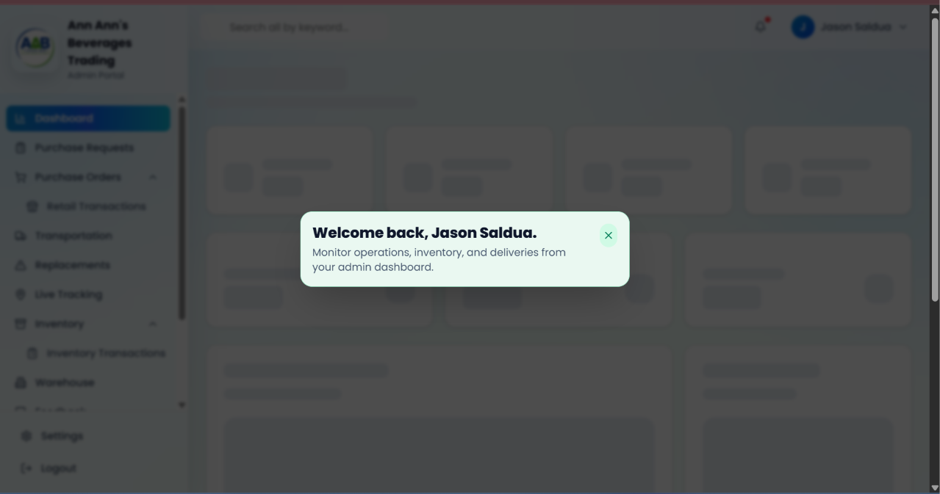
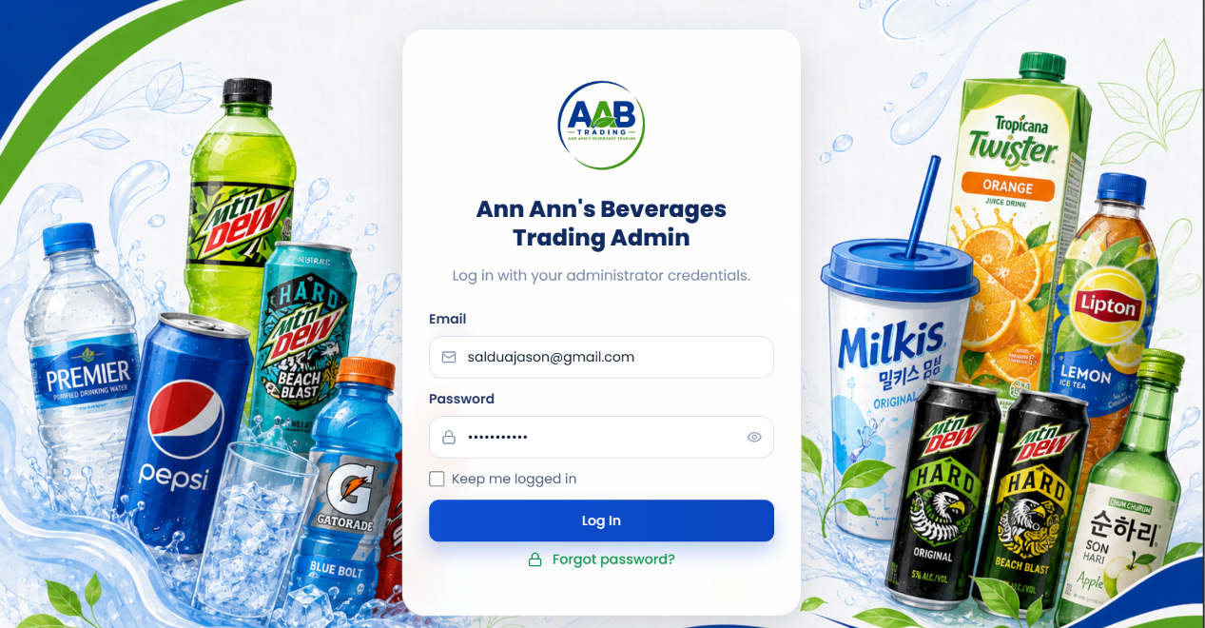
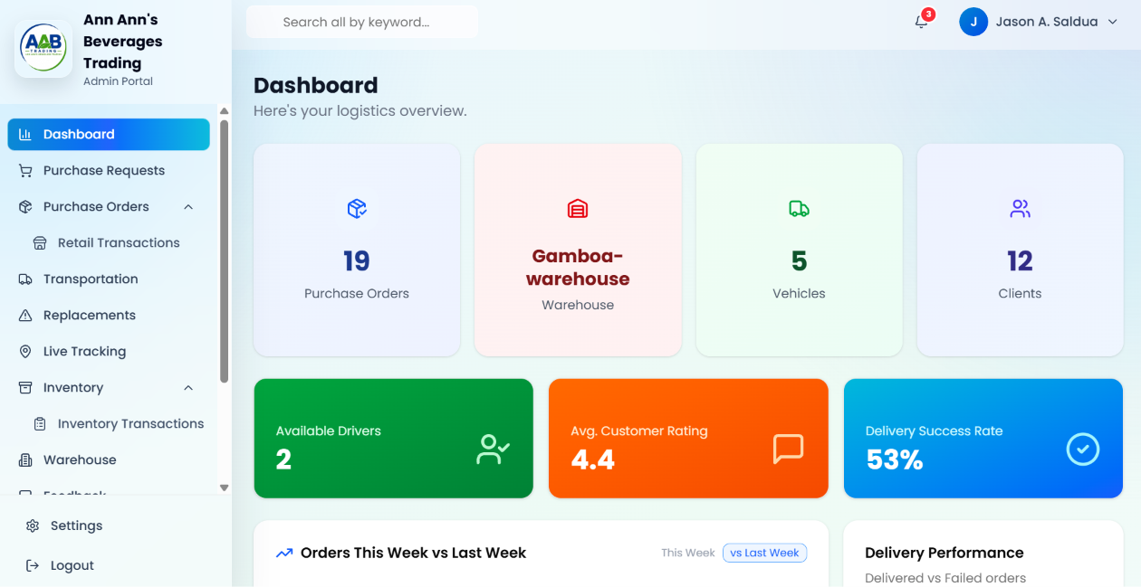
Figure 1
TC-01 - Admin Portal/Dashboard Login
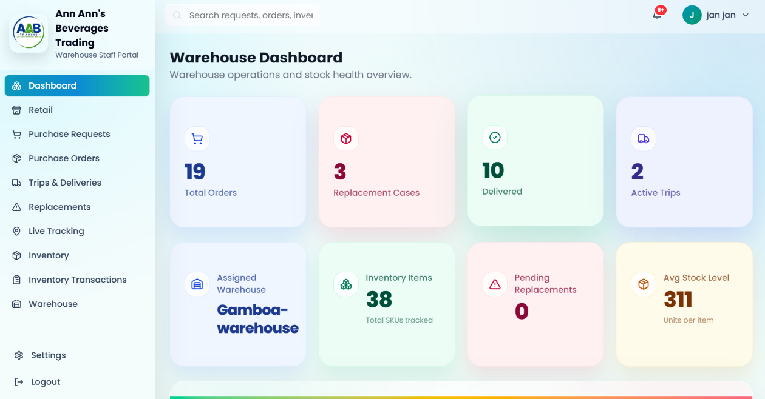
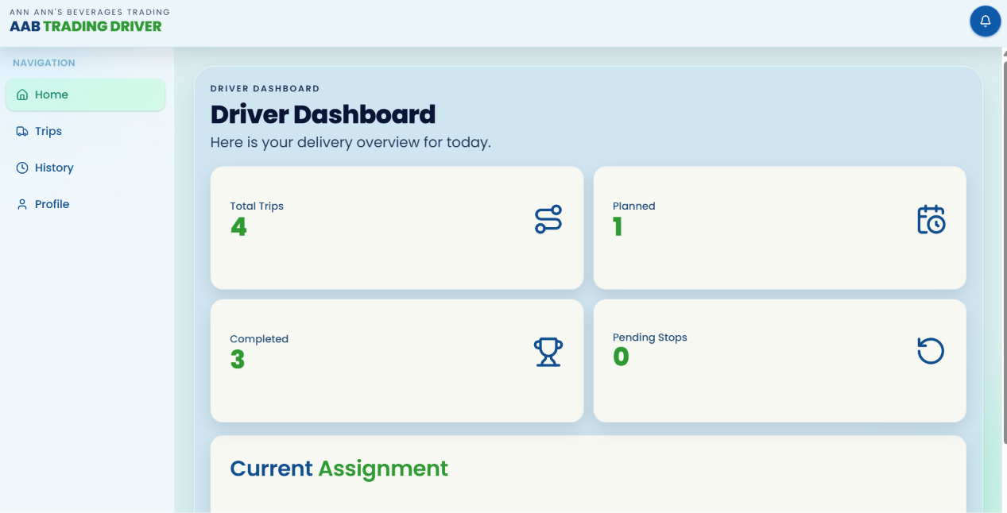
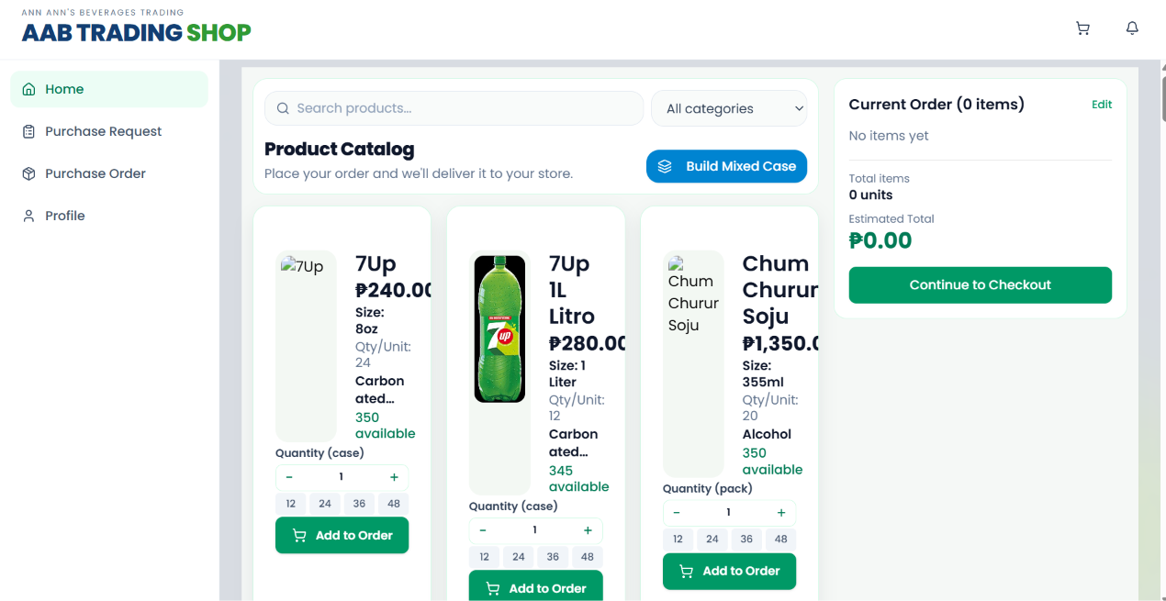
Figure 2
TC-02 - Role-Based Portal Redirection
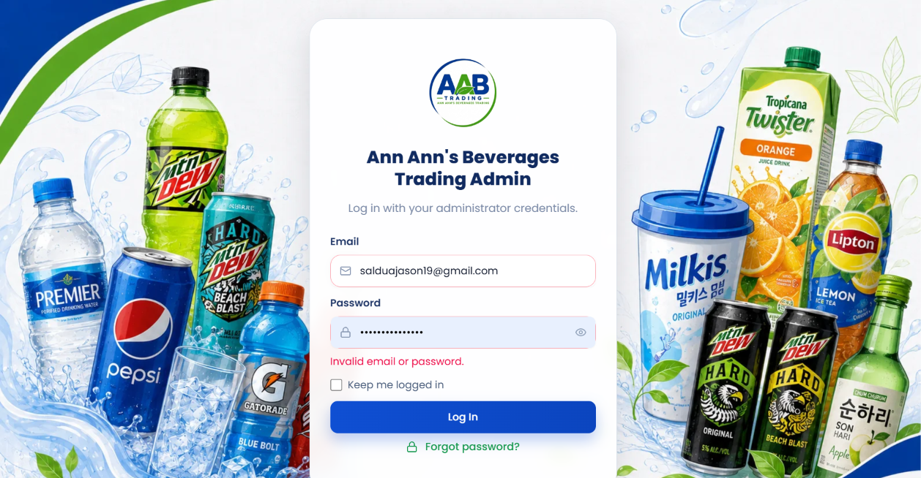
Figure 3
TC-03 - Invalid Login Credentials
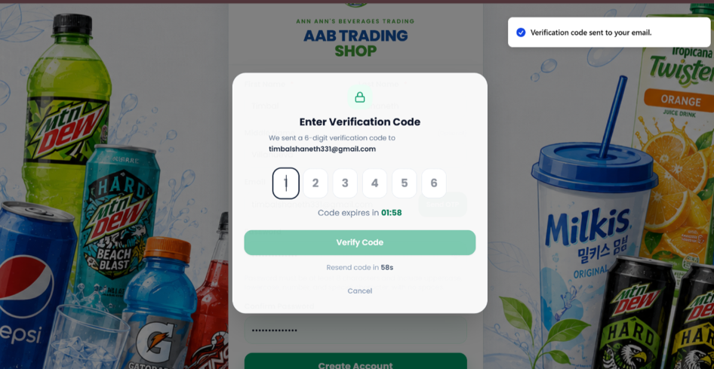
Figure 4
TC-04 - OTP Confirmation

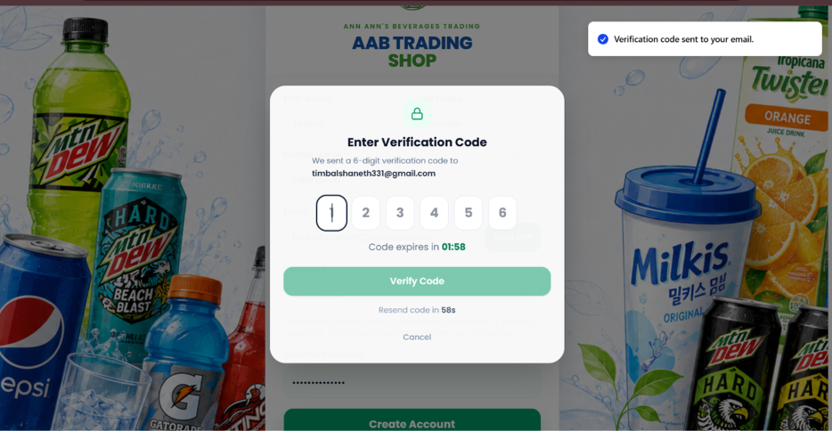
Figure 5
TC-05 - OTP Verification and Account Activation
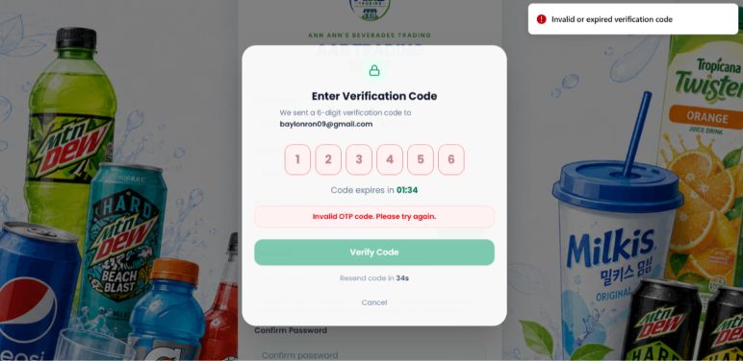
Figure 6
TC-06 - Invalid or Expired OTP
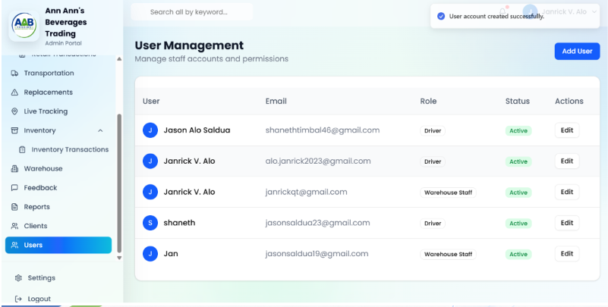
Figure 7
TC-07- Staff/Driver Account Creation
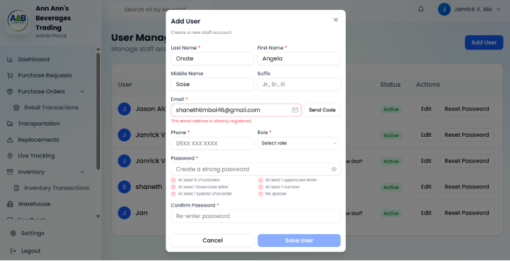
Figure 8
TC-08 - Duplicate Email and Password Validation
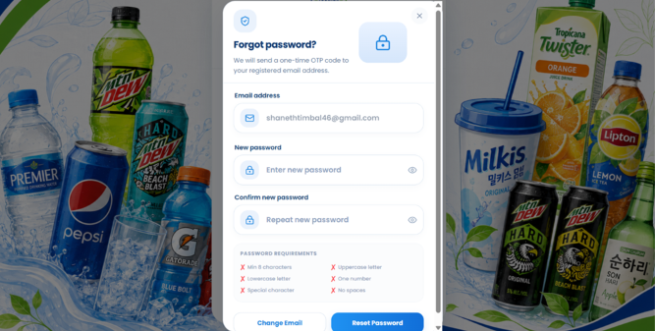
Figure 9
TC-09 - Client Password Reset
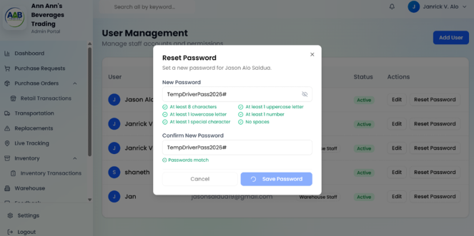
Figure 10
TC-10 - Staff/Driver Password Reset

Table 2
Black-box Testing of the Alpha Testing of Profile Management Case
Test Case ID | Description | Expected Outcome | Actual Outcome | Pass/ Fail | Comments
TC-11 | Manage and Update Employee Profile (Owner / Warehouse Staff / Driver) | The system displays the current profile information, allows the user to update the phone number and profile avatar, saves the changes, and retains the updated information after page reload. | The profile information was displayed, the phone number and profile avatar were updated, the changes were saved successfully, and the updated profile information persisted after refreshing the page during retest. | Pass | Profile updated successfully
TC-12 | Employee Profile Validation on Invalid Phone or Email Format | The system validates the phone and email fields, blocks the submission of invalid information, and displays the appropriate validation messages without changing the original profile data. | The system displayed validation errors for the invalid phone number and email address, blocked the profile update, and retained the original valid profile information. | Pass | Invalid profile data handled correctly
TC-13 | Driver License Details and Document Image Upload | The system displays the license management section, accepts the license details and document image, submits the information successfully, and displays the updated license status. | The Driver Portal displayed the License & Document Management section. License details and the license image were entered and submitted successfully, and the license information was displayed in the driver's profile. | Pass | License details submitted successfully
TC-14 | Manage and Update Client Profile with GPS Map Pin and Delivery Address | The system displays the client profile and interactive map, allows the contact information and delivery location to be updated, saves the delivery profile, and retains the GPS coordinates after page reload. | The Client Profile displayed the delivery information and map. The contact details and map location were updated, the profile was saved successfully, and the saved location remained available after reloading the profile. | Pass | Delivery profile updated successfully
TC-15 | Client Profile Delivery Address Location Validation | The system identifies locations outside the supported delivery area, displays a warning when saving an invalid location, and prevents the out-of-service-area location from being saved. | The system identified the selected location outside Silay and Talisay, displayed the warning notification, and did not save the location as the client's delivery address. | Pass | Invalid delivery location prevented

Evidences:
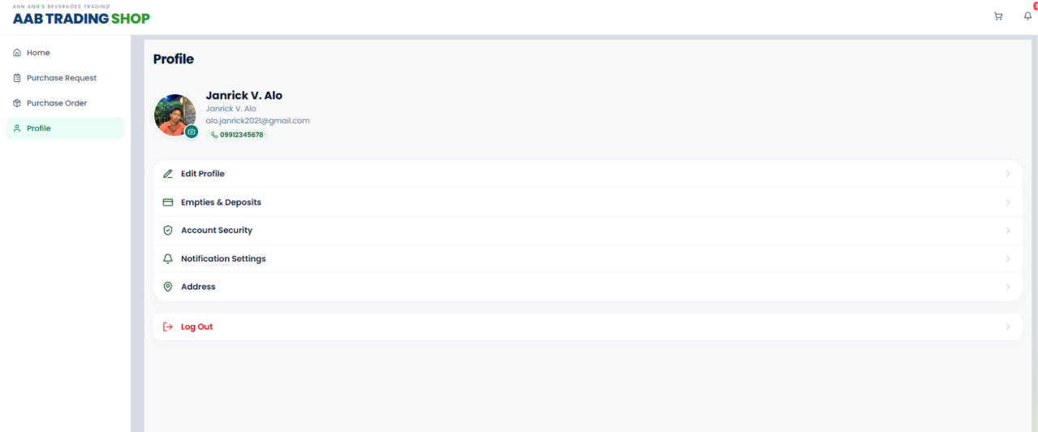
Figure 11
TC-11 - Employee Profile Update
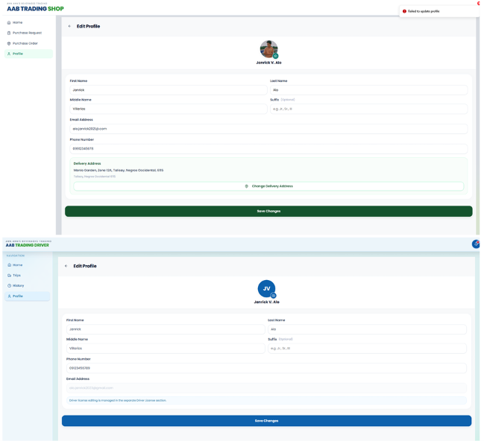
Figure 12
TC-12 - Employee Profile Validation
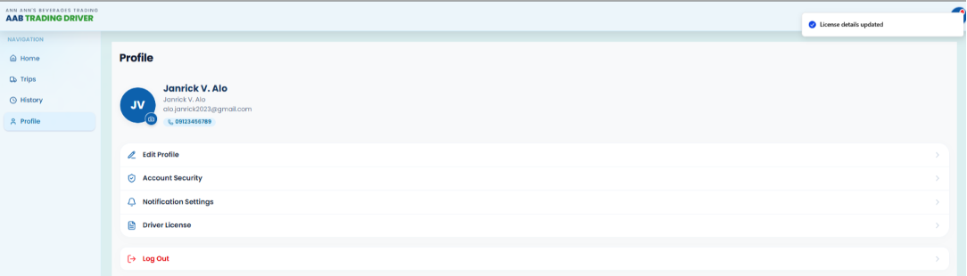

Figure 13
TC-13 - Driver License Details and Document Upload
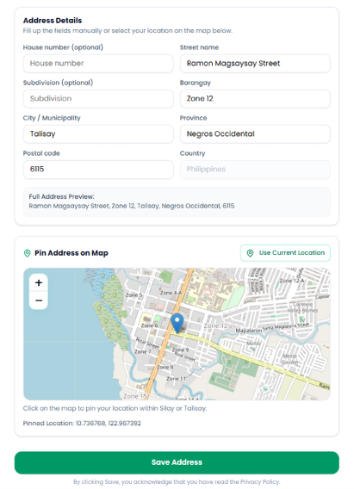
Figure 14
TC-14 - Client Delivery Profile Update

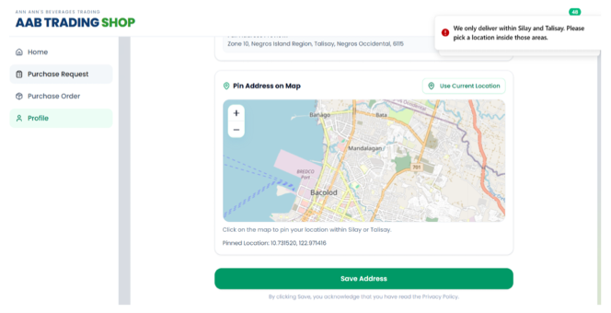
Figure 15
TC-15 - Delivery Address Location Validation

Table 3
Black-box Testing of the Alpha Testing of Master Data Management Case
Test Case ID | Description | Expected Outcome | Actual Outcome | Pass/ Fail | Comments
TC-16 | Register and update delivery vehicle records including plate number, refrigeration specifications, and capacity. | The system displays the vehicle management table, accepts the vehicle specifications, registers the vehicle successfully, and displays it in the active fleet list. | The Vehicle Management page displayed the current fleet. The Add New Vehicle form accepted the vehicle details, and after registration, the vehicle appeared in the fleet list with Available status. | Pass | Vehicle registered successfully
TC-17 | Validate vehicle registration when a duplicate plate number is entered. | The system prevents duplicate vehicle registration and displays a validation message indicating that the plate number already exists. | The system accepted the duplicate plate number in the form but prevented the duplicate registration and displayed the duplicate plate validation. The vehicle list remained unchanged. | Pass | Duplicate plate number prevented
TC-18 | Assign and manage driver-to-vehicle allocation. | The system displays available drivers, allows a driver and vehicle to be assigned, records the assignment, and updates the assignment status. | The Driver-Vehicle Assignments page displayed the available driver. The assignment was successfully created, and the driver and vehicle status were updated to Assigned. | Pass | Driver and vehicle assigned successfully
TC-19 | Prevent conflict on driver or vehicle double assignment. | The system prevents a driver who is currently assigned to an active trip from being reassigned and keeps the original assignment unchanged. | The system identified the driver as currently active on a trip, blocked the conflicting assignment, and retained the original assignment. | Pass | Conflicting assignment prevented
TC-20 | Add and update beverage product catalog records and packaging profiles. | The system opens the product form, accepts product and packaging details, calculates deposit totals, uploads the product image, saves the product, and displays it in the catalog. | The Add Product form accepted the product and packaging information, displayed the deposit values, accepted the product image, and successfully registered the product. The product appeared in the catalog and client shop. | Pass | Product registered successfully
TC-21 | Validate product records with a negative price or missing packaging specifications. | The system prevents saving the product and displays validation messages for the invalid price and missing packaging units per case. | The system displayed the entered negative price and blank packaging field, then prevented the product from being saved and displayed the required validation messages. | Pass | Invalid product data prevented

Results:
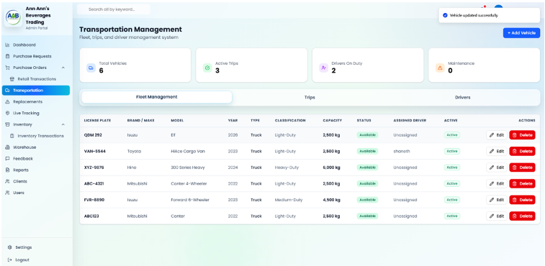
Figure 16
TC-16 - Vehicle Registration
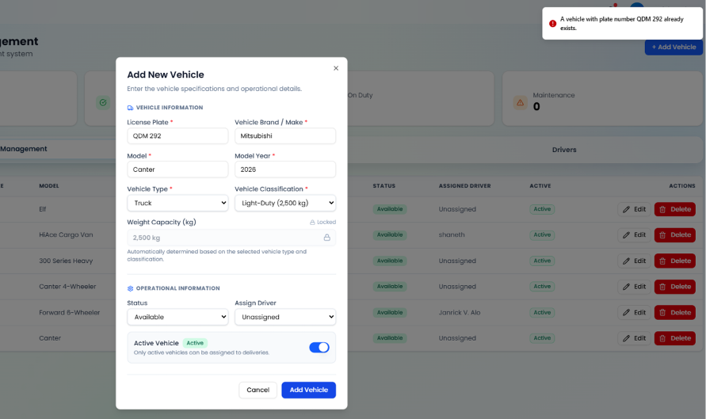
Figure 17
TC-17 - Duplicate Plate Validation
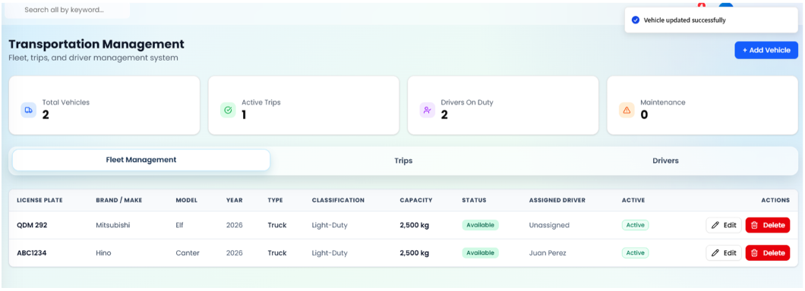
Figure 18
TC-18 - Driver-Vehicle Assignment
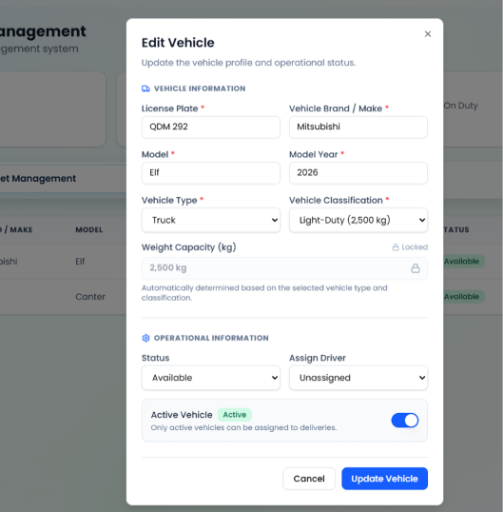
Figure 19
TC-19 - Assignment Conflict Validation
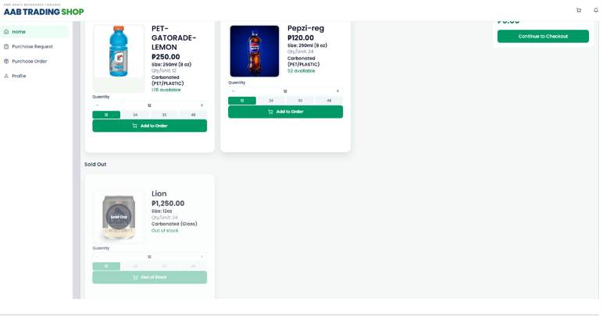
Figure 20
TC-20 - Product Registration
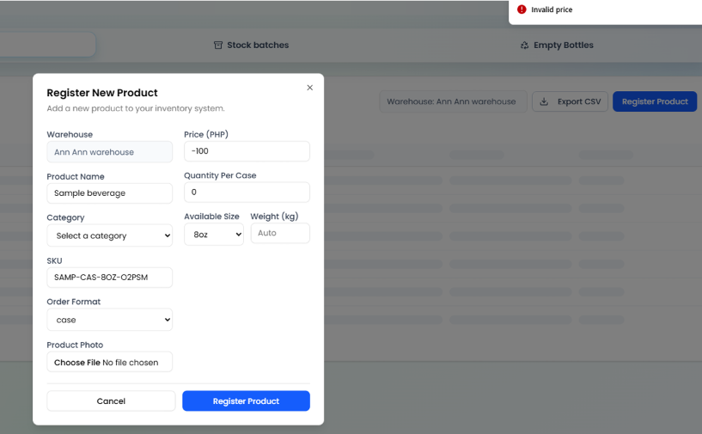
Figure 21
TC-21 - Product Validation

Table 4
Black-box Testing of the Alpha Testing of Inventory Management Case
Test Case ID | Description | Expected Outcome | Actual Outcome | Pass/ Fail | Comments
TC-22 | Receive and categorize stock batch using batch number, expiry, variety, and case count | The system accepts the stock batch details, validates the entered information, updates the inventory quantity, records the stock-in transaction, and displays a confirmation. | The system accepted the selected product, batch details, dates, quantity, and storage information. After confirming the batch, the stock was added to the inventory and the transaction was recorded. | Pass | Stock received successfully
TC-23 | Validate stock receiving with an expired expiration date or zero quantity | The system prevents stock receiving when the expiration date is invalid or the received quantity is zero or negative and displays the required validation messages. | The system displayed validation errors for the invalid expiration date and quantity and prevented the stock batch from being submitted. | Pass | Validation worked correctly
TC-24 | View and verify inventory transaction history and audit trail | The system displays inventory transaction records with the relevant transaction details and allows the user to search, filter, and view transaction information. | The Inventory Transaction History displayed the recorded transactions. Searching for a product and filtering by transaction type and date returned the corresponding records, and the transaction details were displayed when viewed. | Pass | Transaction records displayed correctly
TC-25 | Monitor inventory levels, thresholds, and stock health status | The system displays inventory quantities and stock health indicators and updates the stock information when additional stock is received. | The Inventory page displayed the product stock information, threshold indicators, and stock status. Adding stock updated the available quantity and corresponding stock status. | Pass | Inventory status displayed correctly
TC-26 | Validate stock batch quantity and prevent negative inventory | The system prevents negative or invalid stock quantities, displays the appropriate validation message, and maintains the existing stock quantity. | The Edit Stock Batch dialog displayed the entered negative quantity as invalid, and the system displayed the validation message and prevented the invalid update. | Pass | Negative quantity was prevented

Evidences:
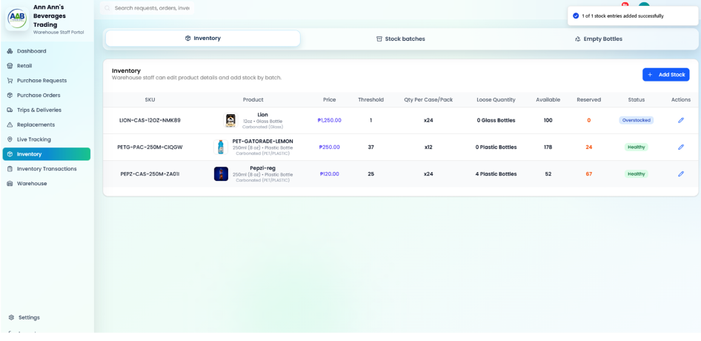
Figure 22
TC-22 -Stock Batch Receiving
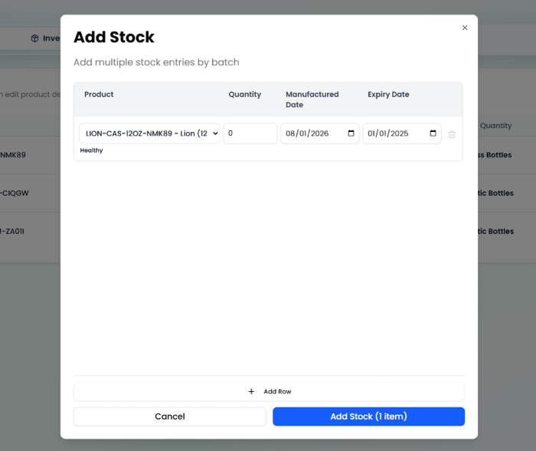
Figure 23
TC-23 - Stock Receiving Validation
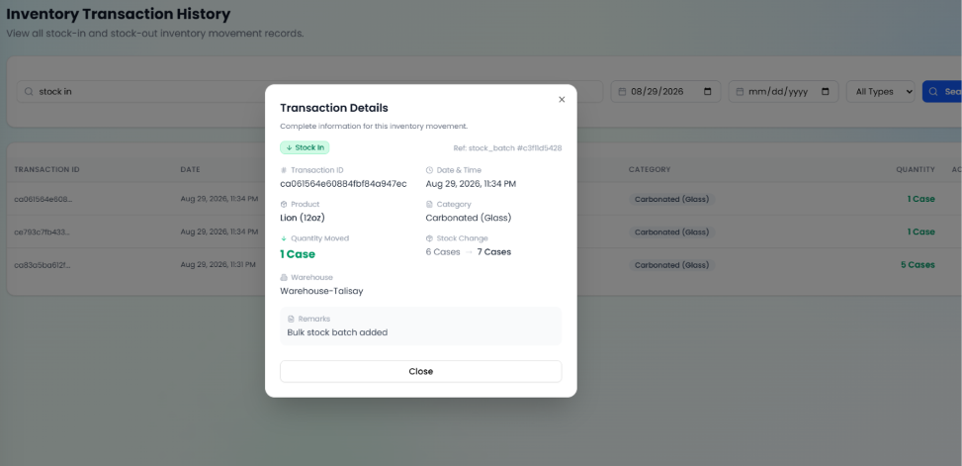
Figure 24
TC-24 - Inventory Transaction History
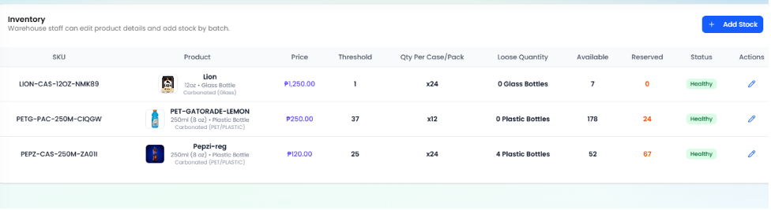
Figure 25
TC-25 - Inventory Stock Monitoring
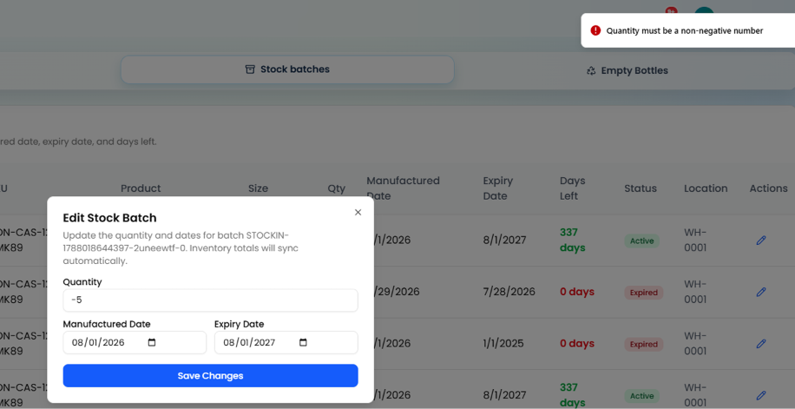
Figure 26
TC-26 - Stock Quantity Validation

Table 5
Black-box Testing of the Alpha Testing of Orderfulfillment and Processing Case
Test Case ID | Description | Expected Outcome | Actual Outcome | Pass/ Fail | Comments
TC-27 | client Places Order Successfully | The system displays the product catalog, allows products to be added to the cart, calculates the order total, accepts the delivery details, and creates the order successfully. | The product catalog displayed the available beverages and prices. Selected items were added to the cart, the order details and total were displayed, and the purchase request was submitted and shown in the Orders section. | Pass | Order placed successfully
TC-28 | Custom Mixed Case Builder | The system allows the client to configure a mixed case, displays the bottle capacity and selected quantities, adds the completed mixed case to the cart, and processes the order. | The Mixed Case Builder displayed the available products and capacity. The selected quantities reached the required case capacity, the mixed case was added to the cart, and the purchase request was submitted successfully. | Pass | Mixed case processed correctly
TC-29 | Prevent Checkout When Requested Order Quantity Exceeds Available Warehouse Stock | The system prevents the client from ordering more cases than the available stock and does not create an order that exceeds inventory. | The system automatically limited the requested quantity to the available stock and prevented the client from exceeding the available inventory. | Pass | Stock limit worked correctly
TC-30 | Prevent Duplicate Fulfillment of Limited Stock Orders | The system allows the orders to be submitted for processing but ensures that available stock is allocated to only one order when the total requested quantity exceeds the available stock. | Both client orders were displayed in the Warehouse Portal. During processing, one order was accepted while the other could not be fulfilled because the product was already out of stock. | Pass | Duplicate fulfillment prevented
TC-31 | Warehouse Staff Filters Approved Purchase Orders and Inspects Itemized Preparation Details | The system displays the Purchase Orders queue, allows filtering and searching of approved orders, and displays the order details and itemized preparation information. | The Purchase Orders queue displayed the order information. The Approved filter and search function displayed the matching order, and the order details showed the client information, items, quantities, and order total. | Pass | Order details displayed correctly
TC-32 | Warehouse Staff Inspects Purchase Order Details and Advances Stage to Ready for Delivery | The system displays the purchase order details, client information, itemized order contents, and allows the warehouse staff to advance the order for delivery. | The Purchase Order Details displayed the order status, client information, delivery details, items, and total. The order was approved/advanced and appeared in the Transportation/Trips section for driver assignment and delivery dispatch. | Pass | Order advanced for delivery

Evidences:
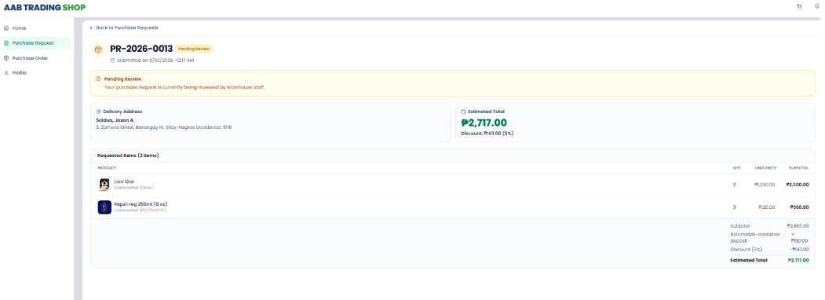
Figure 27
TC-27 - Client Order Placement
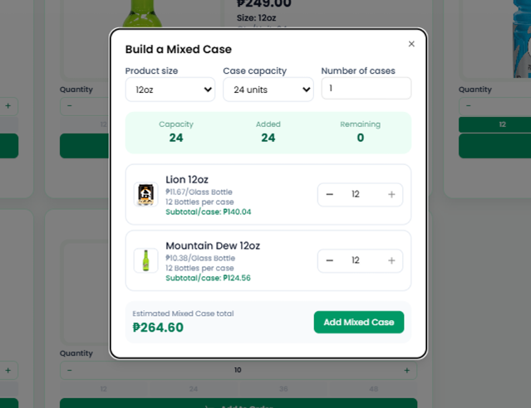
Figure 28
TC-28 - Custom Mixed Case Builder
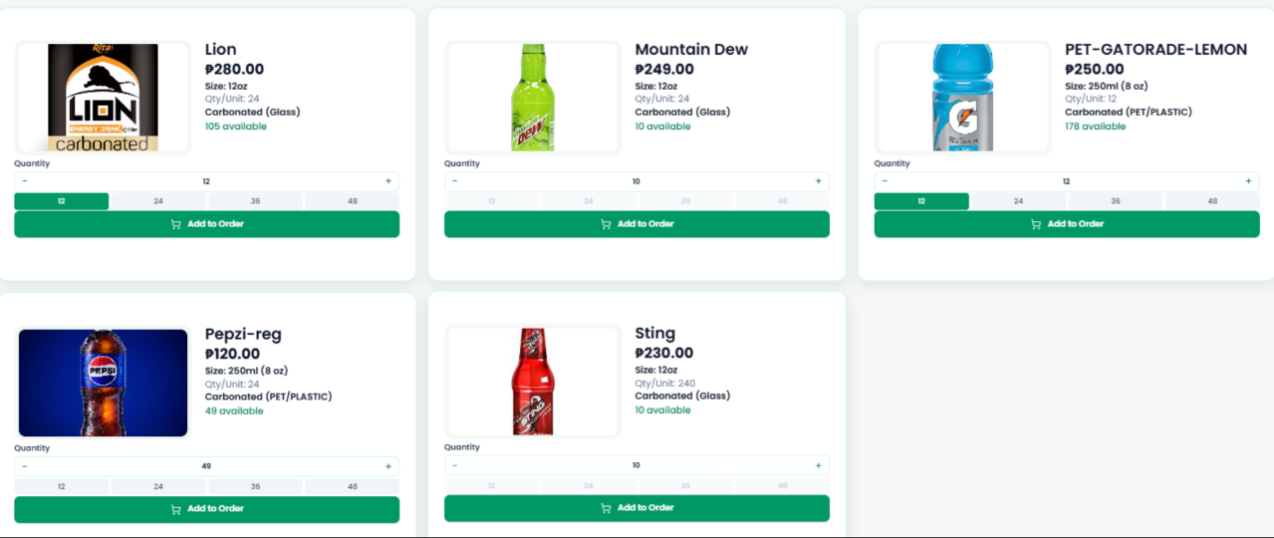
Figure 29
TC-29 - Stock Availability Validation
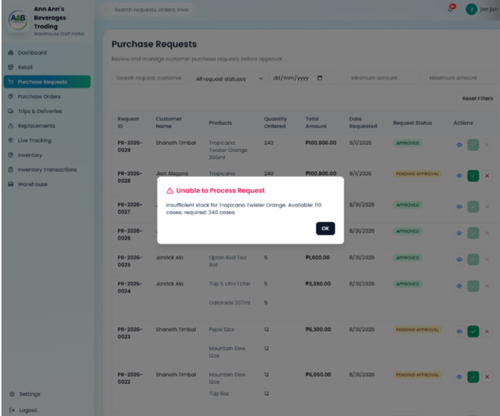
Figure 30
TC-30 - Duplicate Order Fulfillment Prevention
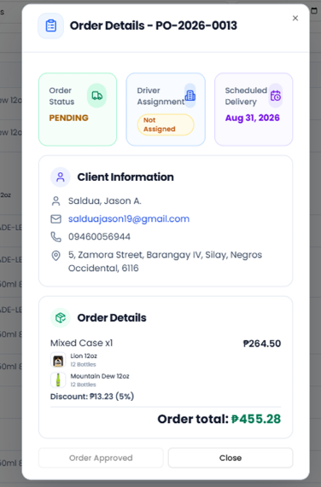
Figure 31
TC-31 - Purchase Order Details
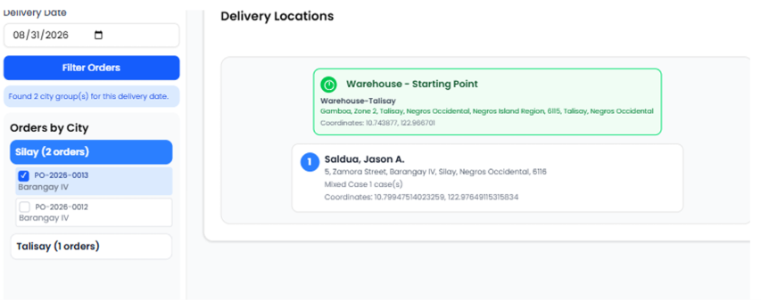
Figure 32
TC-32 - Order Ready for Delivery

Table 6
Black-box Testing of the Alpha Testing of Transportation Management Case
Test Case ID | Description | Expected Outcome | Actual Outcome | Pass/ Fail | Comments
TC-33 | Verify Trip Management page display and navigation for Admin/Dispatcher | The system displays the Transportation module with summary information and provides the Active Trips, Trip History, and Route Planning tabs for navigation. | The Transportation module loaded successfully with the trip information and the Active Trips, Trip History, and Route Planning tabs were displayed and accessible. | Pass | Trip management displayed correctly
TC-34 | Create Delivery Trip with prepared orders and driver assignment | The system allows prepared orders to be selected, assigns an active driver, arranges the delivery stops, validates the trip, and creates the trip in PENDING status. | The prepared orders were selected and bundled, the driver was assigned, the delivery sequence was arranged, and the trip was created successfully. | Pass | Delivery trip created successfully
TC-35 | Validate vehicle capacity when creating a delivery trip | The system prevents dispatch when the selected cargo exceeds the vehicle's maximum capacity and displays the appropriate capacity validation. | The selected orders reached 400 cases, exceeding the vehicle capacity, and the system prevented the trip from being dispatched and displayed the capacity warning. | Pass | Vehicle capacity validation worked correctly
TC-36 | Verify camera and location permission before starting a trip | The system checks camera and location permissions before starting the trip and displays the required permission dialog when access has not been granted. | The Driver Portal displayed the camera and location permission prompt, and the system allowed the required permissions to be granted before proceeding. | Pass | Camera and location permissions worked correctly
TC-37 | Start trip and enable live GPS tracking | The system changes the trip status to IN_TRANSIT, records the departure time, updates linked orders to OUT_FOR_DELIVERY, and records GPS location data. | The trip started successfully, the tracking view was displayed, and the linked order was updated to OUT_FOR_DELIVERY while the trip was in progress. | Pass | Trip tracking worked correctly
TC-38 | Capture Proof of Delivery with GPS and timestamp watermark | The system opens the POD camera, captures the delivery photo, and displays the photo with the current date, time, and GPS coordinates as a watermark. | The POD photo was captured successfully and displayed with the date, time, and GPS coordinate information embedded in the photo. | Pass | POD captured with location and timestamp
TC-39 | Monitor live driver location and route on Admin Tracking View | The system displays the live tracking map with active driver markers, driver information, assigned trip details, destinations, and the route between the warehouse and client stops. | The Admin Tracking View displayed the live map, active driver information, and route polyline connecting the warehouse and client stops. | Pass | Live driver tracking displayed correctly
TC-40 | Client views live delivery tracking and verified POD photo | The system allows the client to view the active delivery status and live map, and after delivery, displays the DELIVERED status, delivery timestamp, and verified POD photo. | The client Portal displayed the active delivery tracking information. After delivery, the order showed the DELIVERED status and the POD photo was available for viewing. | Pass | Client delivery tracking worked correctly
TC-41 | Cancel pending trip and release assigned resources | The system displays a cancellation confirmation, changes the trip status to CANCELLED, releases the assigned orders, and returns the vehicle to AVAILABLE status. | The cancellation was confirmed successfully, the trip was removed/cancelled, and the system displayed the Trip deleted confirmation. | Pass | Pending trip cancelled successfully

Results:
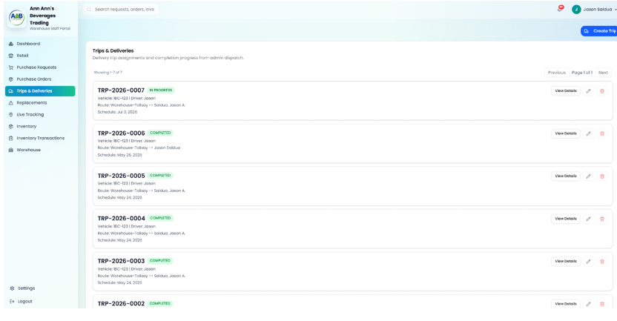
Figure 33
TC-33 - Trip Management Navigation
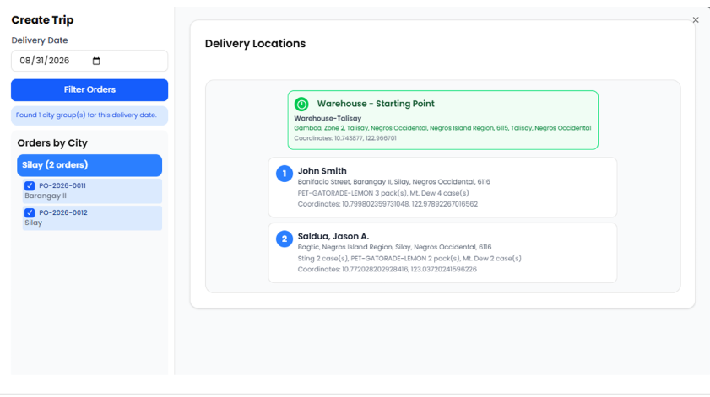
Figure 34
TC-34 - Delivery Trip Creation
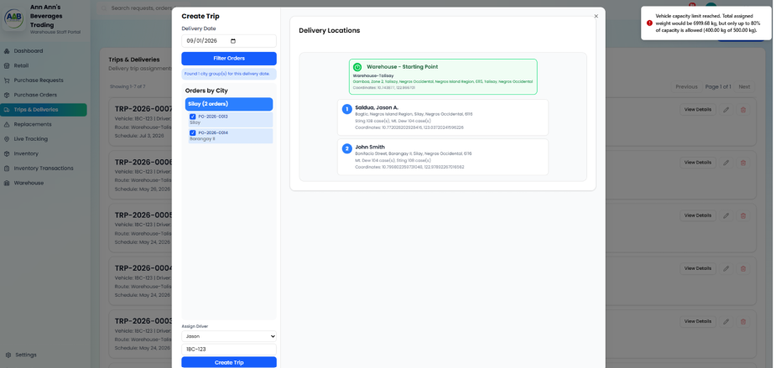
Figure 35
TC-35 - Vehicle Capacity Validation
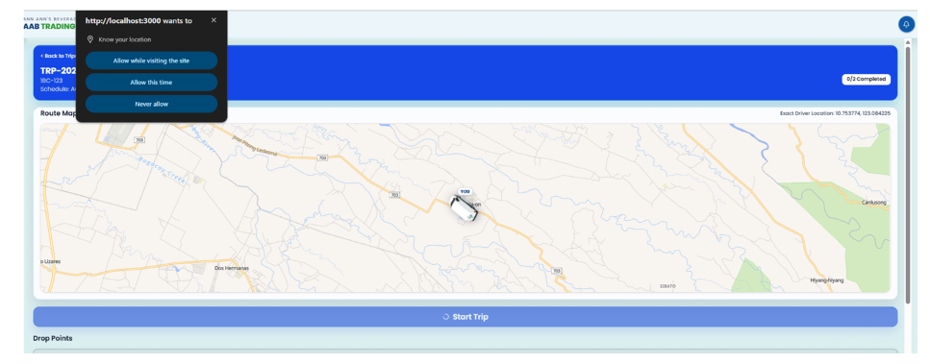
Figure 36
TC-36 - Camera and Location Permission
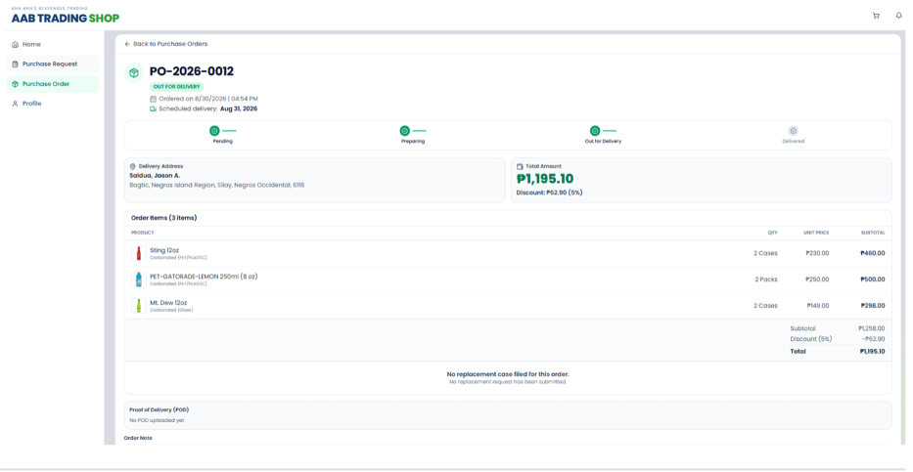
Figure 37
TC-37 - Trip Start and Live GPS Tracking
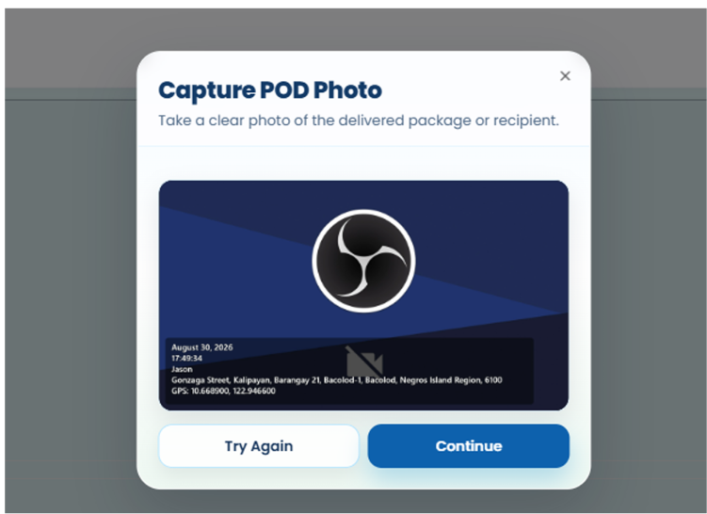
Figure 38
TC-38 - Proof of Delivery Capture

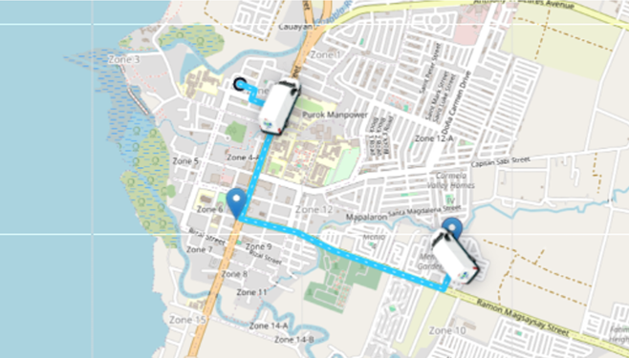
Figure 39
TC-39 - Live Driver Location Tracking
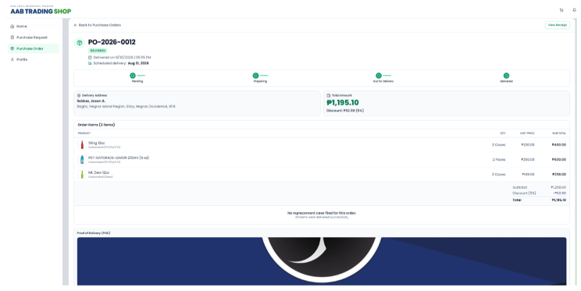
Figure 40
TC-40- Client Delivery Tracking and POD
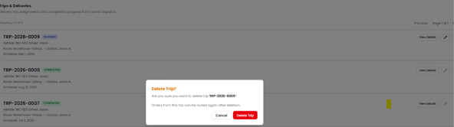
Figure 41
TC- 41- Pending Trip Cancellation


Table 7
Black-box Testing of the Alpha Testing of Replacement Handling Management Case
Test Case ID | Description | Expected Outcome | Actual Outcome | Pass/ Fail | Comments
TC-42 | Client Portal – Submit replacement request for defective or broken bottles on delivered order | The system allows the client to select a delivered order, identify the affected product, enter the replacement quantity and defect reason, provide remarks and photo evidence, and submit the replacement request. | The client Portal displayed the delivered order and replacement form. The affected product, quantity, defect reason, remarks, and photo evidence were entered, and the replacement request was submitted successfully. | Pass | Replacement request submitted successfully
TC-43 | Client Portal – Validate replacement request without required photo evidence | The system prevents submission when photo evidence is not provided and displays the required validation message. | The replacement form was submitted without photo evidence, and the system displayed the validation message requiring photo evidence. | Pass | Photo evidence validation worked correctly
TC-44 | Client Portal – Prevent replacement quantity from exceeding delivered quantity | The system limits the replacement quantity to the delivered quantity and prevents an invalid replacement quantity from being submitted. | The quantity was limited to the maximum delivered quantity, preventing the client from entering a quantity greater than the available delivered quantity. | Pass | Replacement quantity limit worked correctly
TC-45 | Admin/Warehouse Portal – View replacement claims and filter by status | The system displays the replacement claims list with status tabs and allows claims to be filtered according to their current status. | The Replacements page displayed the claims list and status tabs. Selecting Pending Verification filtered the list to the claims awaiting review. | Pass | Replacement claims displayed correctly
TC-46 | Admin/Warehouse Portal – Inspect replacement claim details and photo evidence | The system displays the client information, order details, defect information, remarks, and uploaded photo evidence for the selected replacement claim. | The Replacement Details view displayed the client information, order details, defect reason, notes, replacement items, and photo evidence. | Pass | Claim details displayed correctly
TC-47 | Admin/Warehouse Portal – Approve replacement claim | The system allows the authorized user to approve a valid replacement claim and updates the claim status to VERIFIED. | The replacement claim was reviewed and approved. The system updated the claim status to VERIFIED and displayed the updated status in the replacement records. | Pass | Replacement claim verified successfully
TC-48 | Admin/Warehouse Portal – Reject replacement claim with required reason | The system requires a rejection reason and prevents confirmation when the reason is blank. After confirmation, the replacement claim is marked as REJECTED. | The system required a rejection reason before confirmation. After a reason was entered and the rejection was confirmed, the claim was updated as REJECTED. | Pass | Replacement rejection handled correctly
TC-49 | Warehouse Portal – Schedule replacement redelivery and assign delivery date | The system allows a verified replacement case to be scheduled for redelivery by selecting a delivery date and updates the replacement case accordingly. | The verified replacement case was opened, a delivery date was selected, and the replacement redelivery was successfully scheduled. | Pass | Replacement redelivery scheduled successfully
TC-50 | Warehouse & Driver Portal – Assign driver, create trip, and complete replacement redelivery with POD | The system allows the warehouse staff to assign a driver and vehicle, create the trip, display the replacement stop in the Driver Portal, capture proof of delivery, and complete the redelivery. | The replacement stop was added to the trip, a driver and vehicle were assigned, and the trip was created. The assigned trip appeared in the Driver Portal, the replacement delivery was performed, and POD evidence was captured for completion. | Pass | Replacement redelivery completed successfully

Results:
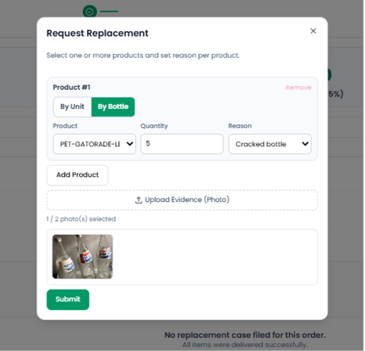
Figure 42
TC-42 - Submitted Replacement Request with Confirmation Message

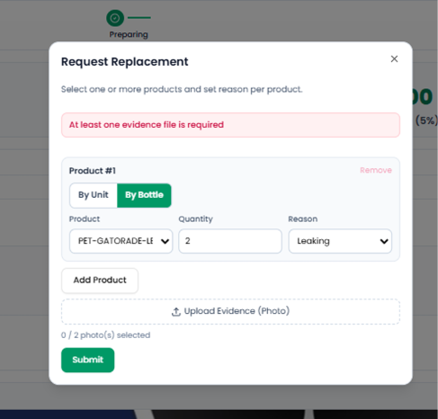
Figure 43
TC-43 - Replacement Request Validation for Missing Photo Evidence
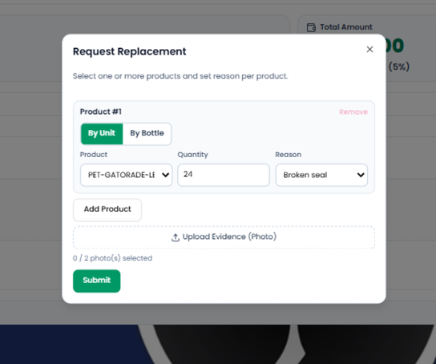
Figure 44
TC-44 - Replacement Quantity Limited to Delivered Quantity
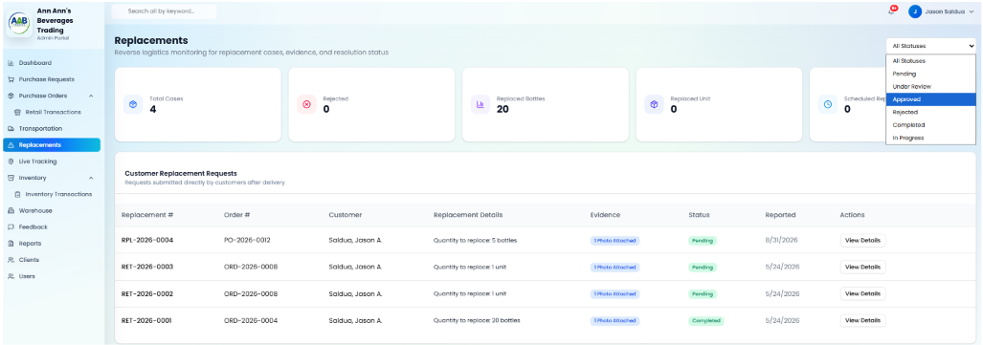
Figure 45
TC- 45- . Replacement Claims List with Status Filters
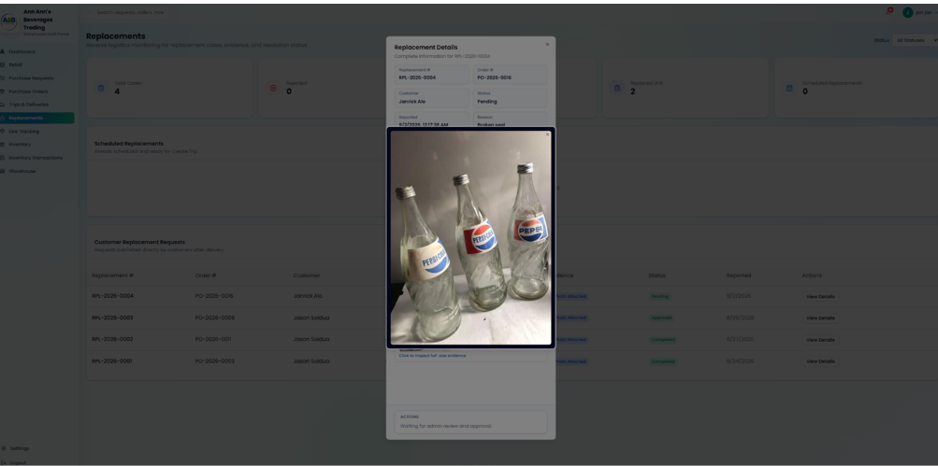
Figure 46
TC-46 - Replacement Claim Details and Photo Evidence
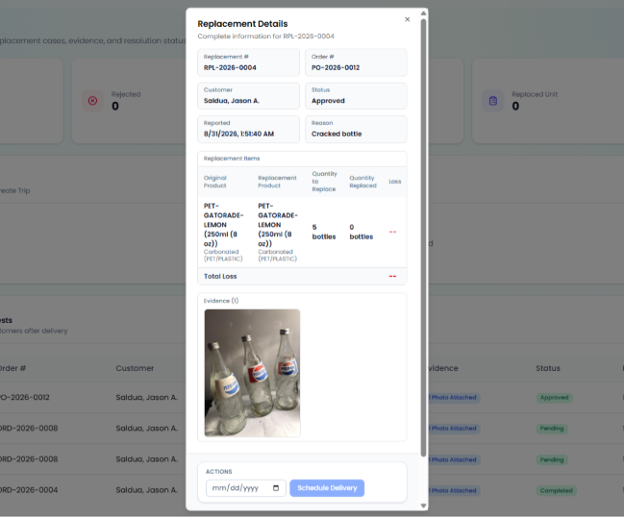
Figure 47
TC- 47- Replacement Claim Successfully Verified
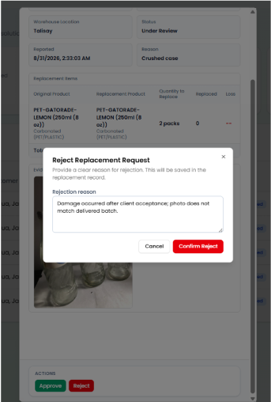
Figure 48
TC- 48- Replacement Claim Rejection with Required Reason
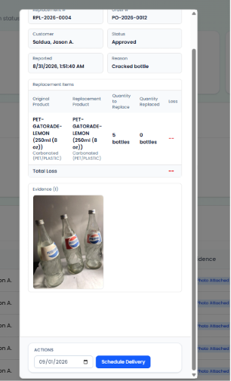
Figure 49
TC-49 - Replacement Redelivery Successfully Scheduled
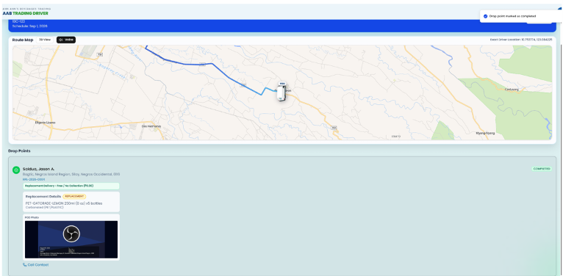
Figure 50
TC-50 - Completed Replacement Redelivery with Proof of Delivery

Table 8
Black-box Testing of the Alpha Testing of Feedback Management Case
Test Case ID | Description | Expected Outcome | Actual Outcome | Pass/ Fail | Comments
TC-51 | Client Portal - Submit 1-to-5 star rating and category review on delivered order | Delivered orders are listed with Rate & Review buttons. The rating modal displays the interactive star rating and feedback options. The selected rating and feedback option are applied, and submitting the review saves the feedback and displays a confirmation message. | The client Portal displayed the delivered order with the Rate & Review button. The review modal opened and displayed the star rating and feedback options. The rating and Professional driver feedback option were selected, and the review was submitted successfully with a confirmation notification. | Pass | Feedback submitted successfully
TC-52 | Client Portal - Prevent duplicate feedback submissions on the same order | The Orders list loads, a previously reviewed delivered order displays the Feedback Submitted badge or star rating summary, and the user cannot submit another feedback entry for the same order. | The client Portal displayed the orders list. The previously reviewed order showed its feedback and rating information, and the system prevented another feedback submission for the same order. | Pass | Duplicate feedback was prevented
TC-53 | Admin Feedback Management - View feedback list, CSAT metrics, and star distribution | The Feedback Management view loads and displays the KPI metrics, star rating distribution, and feedback table with client, order, rating, category, comments, and date information. | The Client Feedback page loaded successfully. The KPI cards, rating distribution, satisfaction trend, feedback search/filter, and feedback records were displayed. | Pass | Feedback information displayed correctly
TC-54 | Admin Feedback Management - Filter feedback by star rating (1 to 5 stars) and category | Selecting the 1 Star or Complaints filter updates the table to show the matching feedback records, while selecting All Ratings restores the complete feedback list. | The feedback list was filtered using the rating option, and selecting All Ratings restored the full list of feedback records. | Pass | Feedback filtering worked correctly

Results:
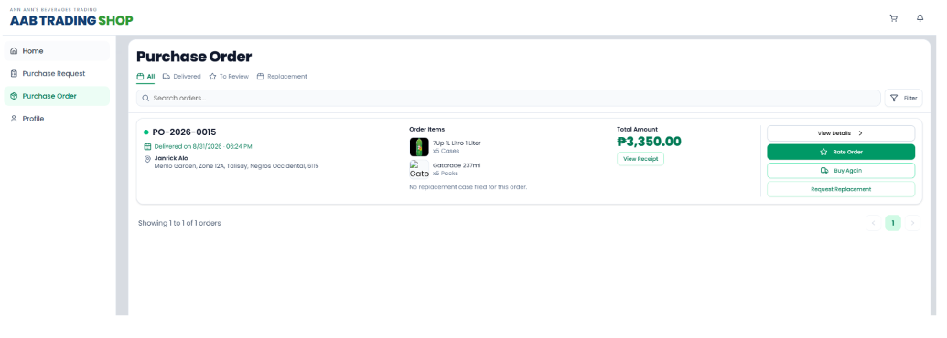
Figure 51
TC-51 - Rate and Review Delivered Order
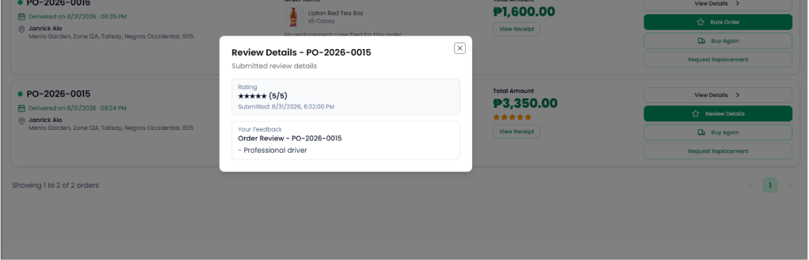
Figure 52
TC-52 - Prevent Duplicate Feedback Submission
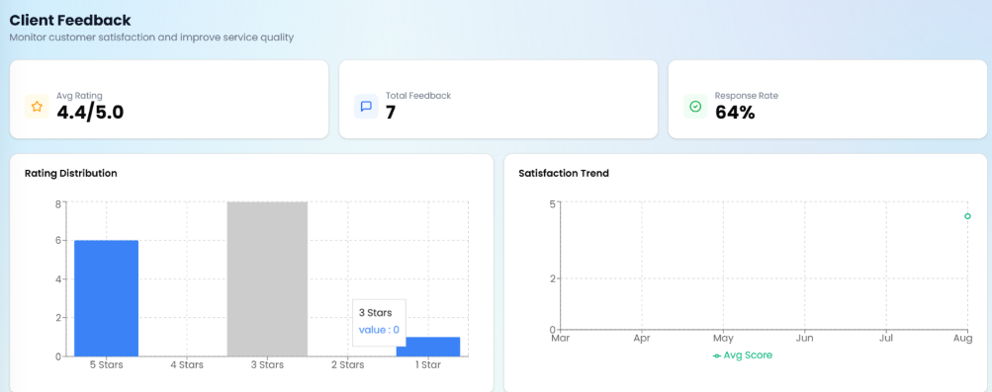
Figure 53
TC- 53- Feedback Management Dashboard
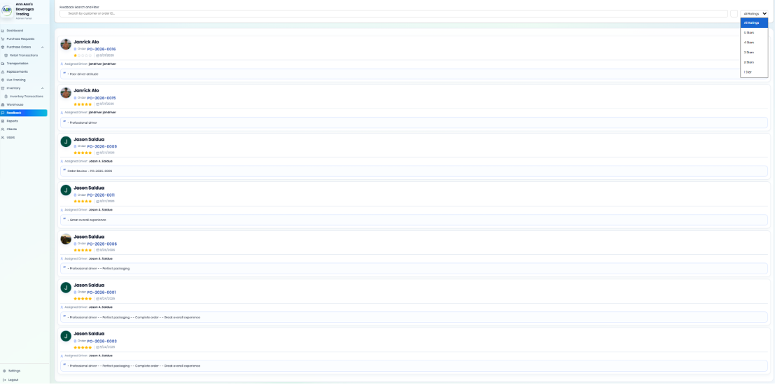
Figure 54
TC-54 - Feedback Rating Filter

Table 9
Black-box Testing of the Alpha Testing of Report Generation Case
Test Case ID | Description | Expected Outcome | Actual Outcome | Pass/ Fail | Comments
TC-55 | Admin Reports - Access control and module navigation | The sidebar displays Reports, the Reports & Analytics dashboard loads, and the available report tabs are displayed and interactive. | The Reports option was displayed in the Admin Portal. The Reports & Analytics dashboard loaded successfully and the report tabs were displayed. | Pass | Reports module displayed correctly
TC-56 | Generate Retail Sales Report with Date Range and Sales Channel Filters | The Retail Sales Report view is displayed, the This Month date filter applies to the current calendar month, All Channels includes orders from the Client Portal and Retail POS, and the report displays the required KPI cards and sales records. | The Retail Sales Report was displayed. The This Month and All Channels filters were available and selected. The KPI cards and retail sales data table were displayed with the corresponding report fields. | Pass | Retail Sales report displayed correctly
TC-57 | Generate Transportation & Driver Performance Report | The Logistics & Delivery Records report is displayed with trip and delivery performance metrics, records are filtered according to the selected date and driver filters, and the report can be downloaded as a PDF. | The Logistics & Delivery Records report was displayed. The Past 30 Days and All Assigned Drivers filters were applied, logistics records were displayed, and the report was successfully downloaded as a PDF. | Pass | Transportation report exported successfully
TC-58 | Generate Warehouse & Inventory Movement Report with transaction type filter | The Warehouse & Inventory report displays inventory movement and product velocity information, applies the selected date, category, and sorting filters, and can be downloaded as a PDF. | The Warehouse & Inventory report was displayed. The Past 30 Days, All Categories, and sorting options were applied. Product and inventory information were displayed, and the report was successfully downloaded as a PDF. | Pass | Warehouse report exported successfully
TC-59 | Generate Defective Product & Replacement Report | The Replacement Records Report is displayed with replacement summary metrics and filters, and records are filtered according to the selected date, replacement status, and reason. | The Replacement Records Report was displayed. The Past 30 Days, All Replacement Status, and All Reasons filters were applied, and the replacement records table was displayed. | Pass | Replacement report displayed correctly
TC-60 | Generate client Feedback & Satisfaction (CSAT) Report | The Feedback Report displays the date filter, export options, KPI metrics, ratings distribution, and feedback records, and the report can be downloaded as a PDF. | The Feedback Report was displayed with the Past 30 Days filter. The KPI information, ratings distribution, and feedback records were displayed, and the Feedback Report was successfully downloaded as a PDF. | Pass | Feedback report exported successfully
TC-61 | Export Report to CSV - Structured file generation and data verification | The Purchase Requests Report is displayed, the report is downloaded as a CSV file, the file opens with the appropriate column headers and data rows, and the exported data matches the report without missing or incorrect values. | The Purchase Requests Report was displayed. The CSV file was successfully downloaded and opened in a spreadsheet. The exported records and columns were displayed and matched the report data. | Pass | CSV report exported successfully
TC-62 | Download Report as PDF - Printable layout with header and KPI summary cards | The system initiates the PDF compilation, downloads the PDF file, and displays the report with the organization title, date stamp, summary KPI boxes, formatted table rows, and clean pagination. | The report was successfully downloaded as a PDF. The generated file displayed the organization title, report information, KPI summary, formatted records, and a proper printable layout. | Pass | PDF report generated successfully
TC-63 | Report Export Error Handling - Empty dataset triggers warning toast | The Purchase Requests Report displays no records for the selected period, the system displays a notification indicating that there is no data to export, and no empty or corrupt CSV file is generated. | A future date with no records was selected. The Purchase Requests Report displayed no records, and the system displayed a “No records available to export” notification. No CSV file was generated. | Pass | Empty export handled correctly

Results:
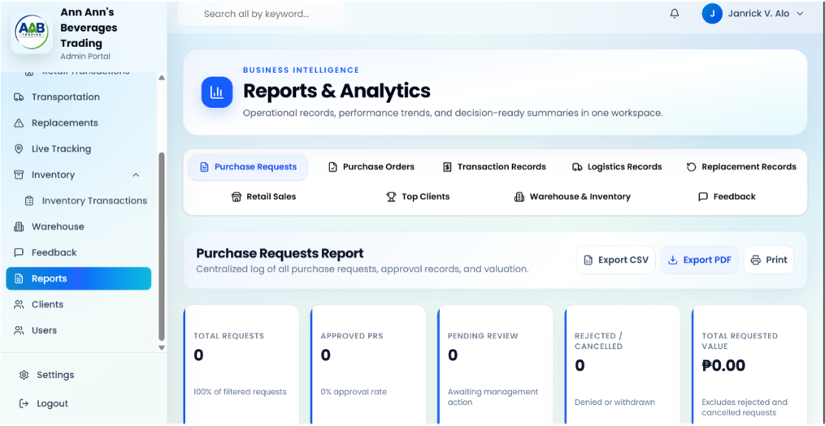
Figure 55
TC-55 - Admin Reports and Analytics Dashboard
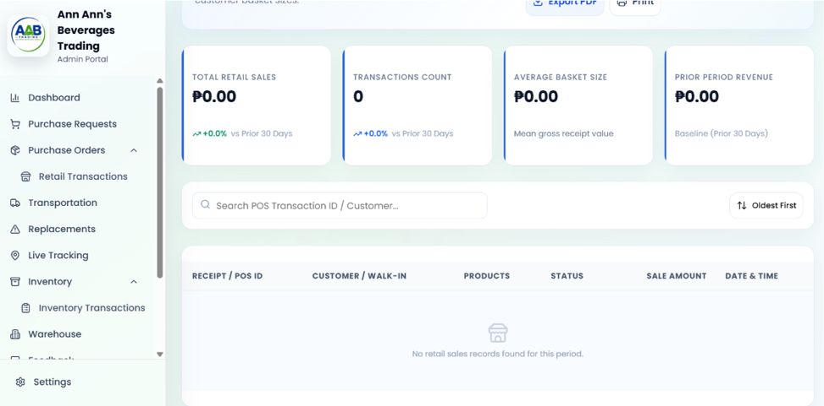
Figure 56
TC-56 - Retail Sales Report
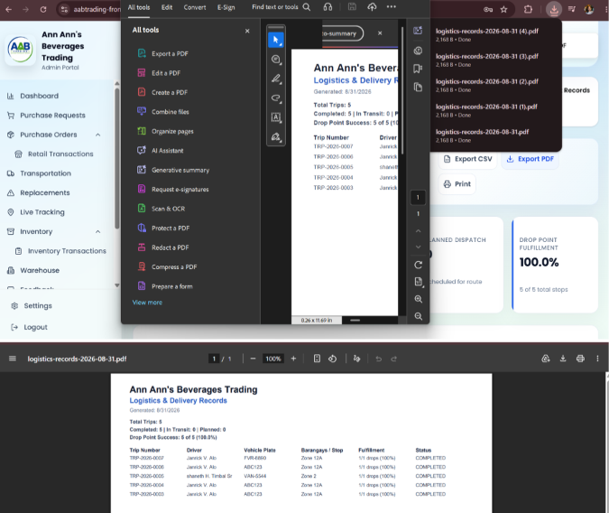
Figure 57
TC-57 - Transportation and Driver Performance Report
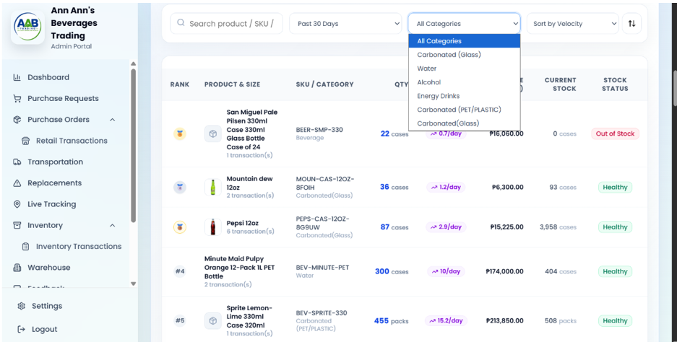
Figure 58
TC-58 - Warehouse and Inventory Movement Report
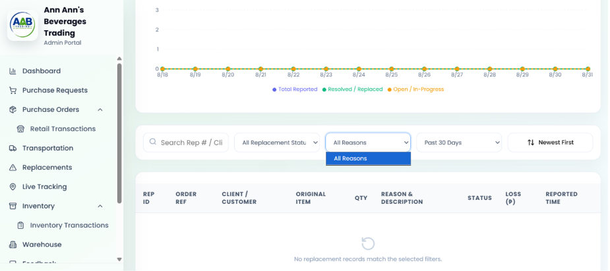
Figure 59
TC-59 - Defective Product and Replacement Report
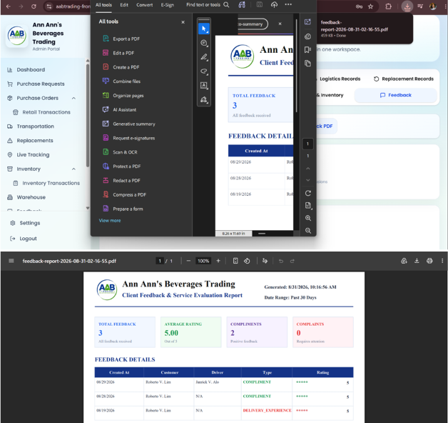
Figure 60
TC-60 - client Feedback and Satisfaction Report
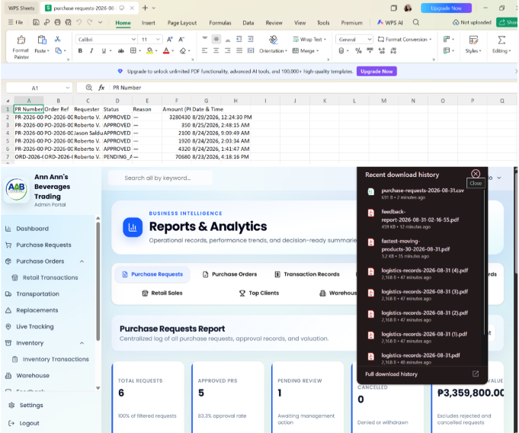
Figure 61
TC-61 - Purchase Requests Report Exported to CSV
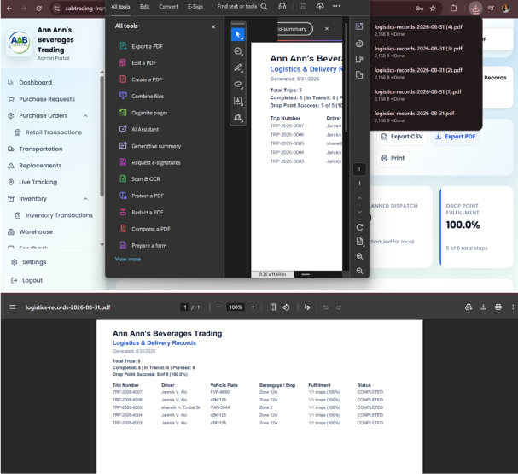
Figure 62
TC-62 - Generated Report in PDF Format
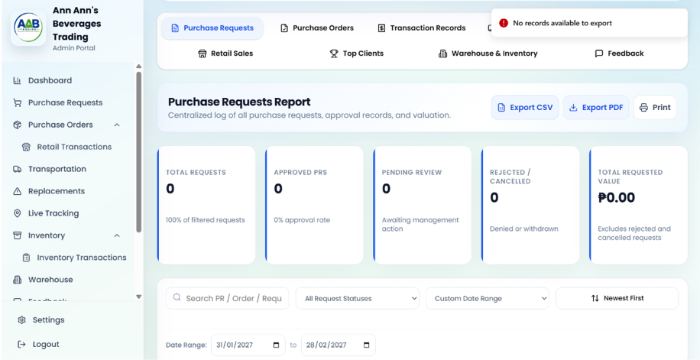
Figure 63
TC-63 - Empty Report Export Warning

Table 10
Summary of Main Process Results
Module | Main Process Tested | Result
Registration and Authentication | Login, role-based access, client registration, OTP verification, account creation, and password reset | Passed
Profile Management | Employee profile updates, profile validation, driver license information, client delivery address, and location validation | Passed
Master Data Management | Vehicle registration, duplicate plate validation, driver-vehicle assignment, product registration, and product validation | Passed
Inventory Management | Stock receiving, stock validation, transaction history, inventory monitoring, and prevention of invalid quantities | Passed
Order Fulfillment and Processing | client ordering, mixed case ordering, stock limitation, order fulfillment, purchase order inspection, and order advancement | Passed
Transportation Management | Trip management, delivery trip creation, vehicle capacity validation, driver trip activation, GPS tracking, proof of delivery, live delivery tracking, and trip cancellation | Passed
Replacement Handling Management | Replacement request submission, request validation, claim verification, rejection, redelivery scheduling, driver assignment, and replacement delivery with proof of delivery | Passed
Feedback Management | Client feedback submission, duplicate feedback prevention, feedback monitoring, and rating/category filtering | Passed
Report Generation | Report access, report generation, filtering, data display, CSV/PDF export, and empty-data handling | Passed

CYPRESS EVIDENCE FOR 63 BLACK-BOX TEST CASES
Alpha Black-Box Testing — Complete Automated Evidence Appendix
Test runner | Cypress 13.17.0
Browser | Chrome 153 (headless)
Specification | cypress/e2e/alpha-blackbox.cy.ts
Document cases | 63
Passing | 63
Failing / pending / skipped | 0 / 0 / 0
Screenshots | 63 case-specific captures
Evidence source | test-results/alpha-blackbox-contract-evidence.json
Run timestamp | 2026-09-23T16:37:31.759776+00:00
Result | PASS — all documented cases covered
Evidence method: Cypress executed one named automated checkpoint for every TC-01 through TC-63 entry. Each image below was captured during that successful Cypress run and shows the mapped executable check and its observed result.

Cypress Evidence — Authentication
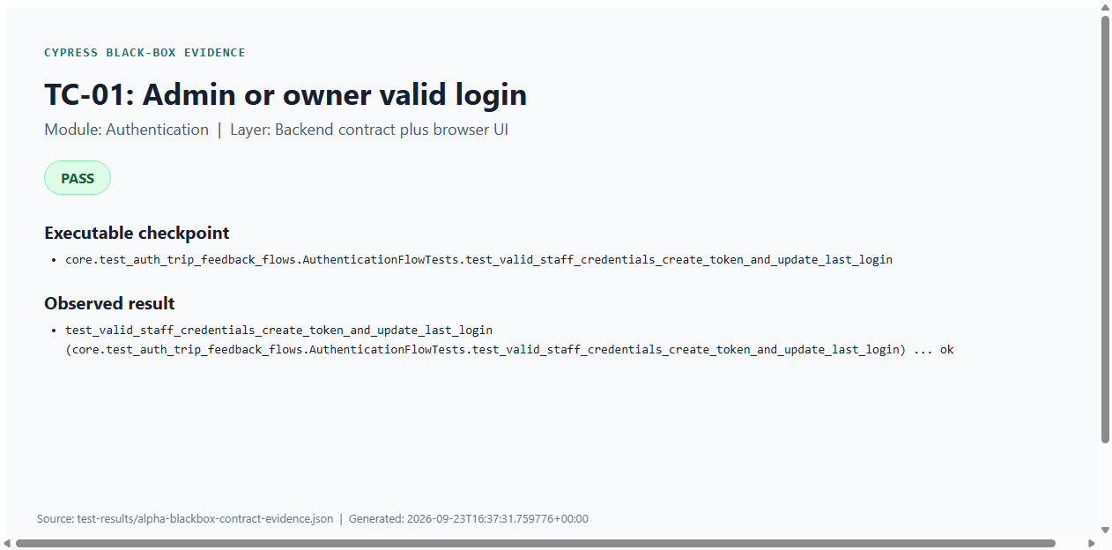
Figure C1: TC-01 — Admin or owner valid login (Cypress PASS evidence)
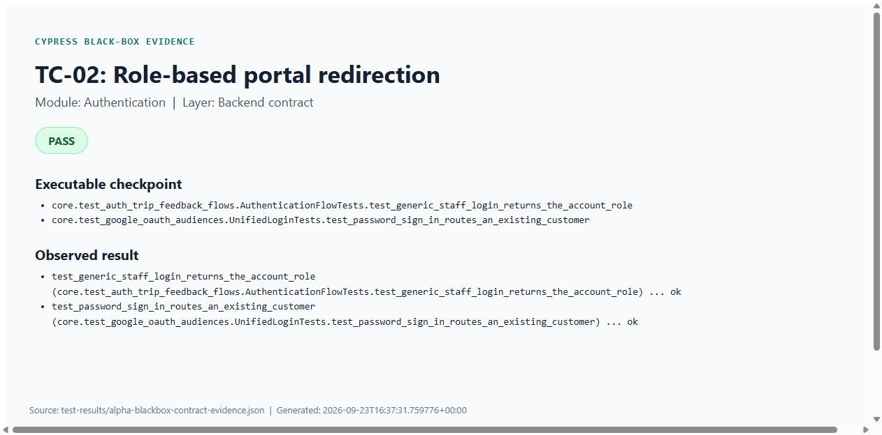
Figure C2: TC-02 — Role-based portal redirection (Cypress PASS evidence)

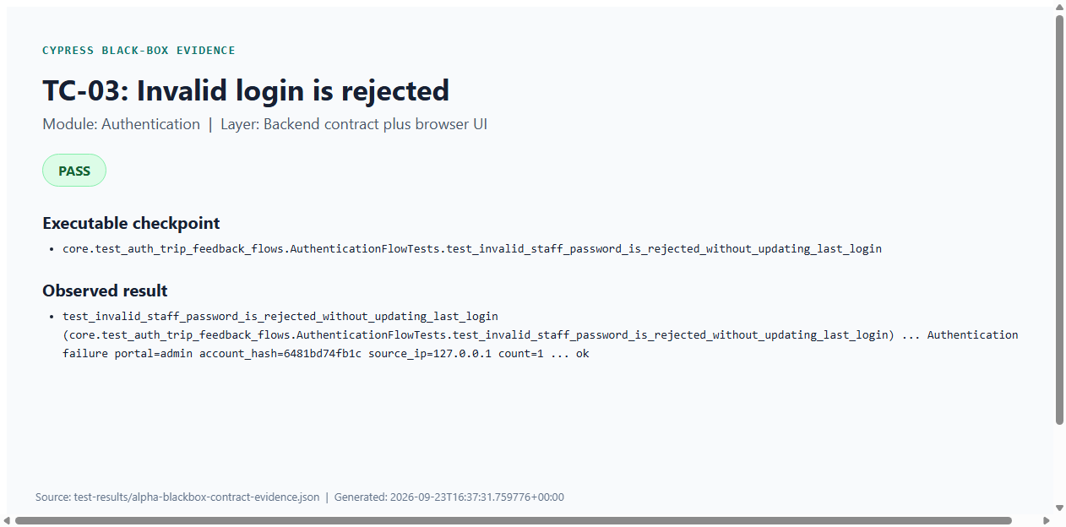
Figure C3: TC-03 — Invalid login is rejected (Cypress PASS evidence)
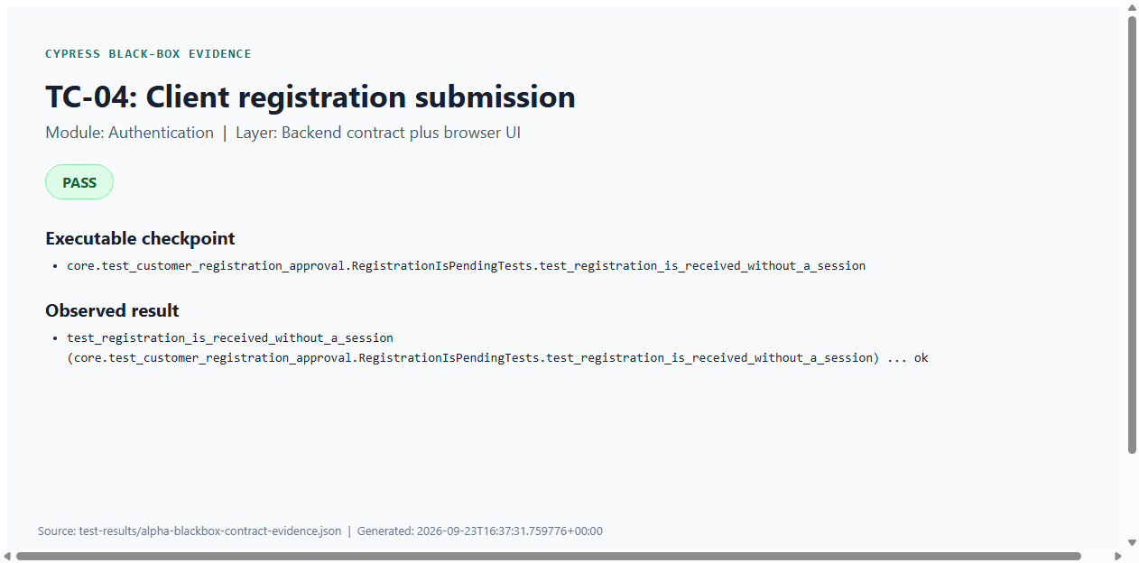
Figure C4: TC-04 — Client registration submission (Cypress PASS evidence)

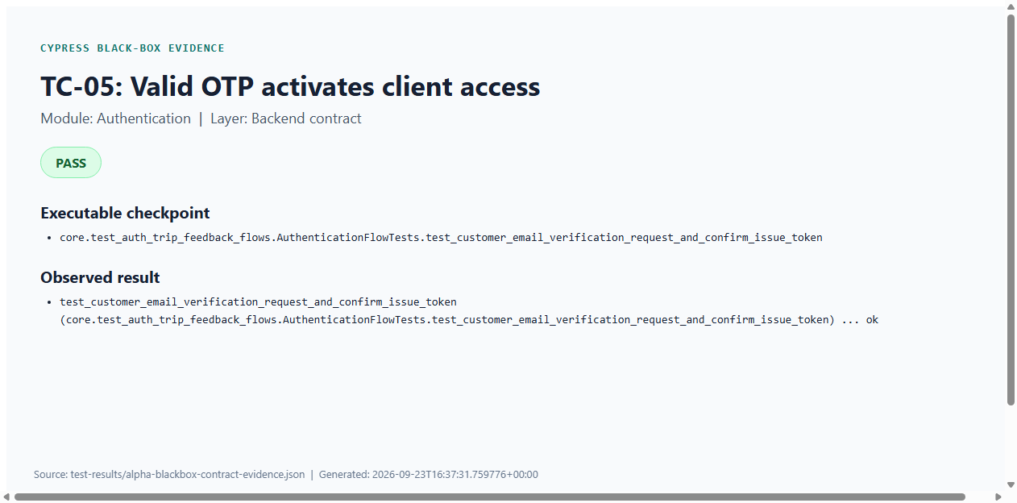
Figure C5: TC-05 — Valid OTP activates client access (Cypress PASS evidence)
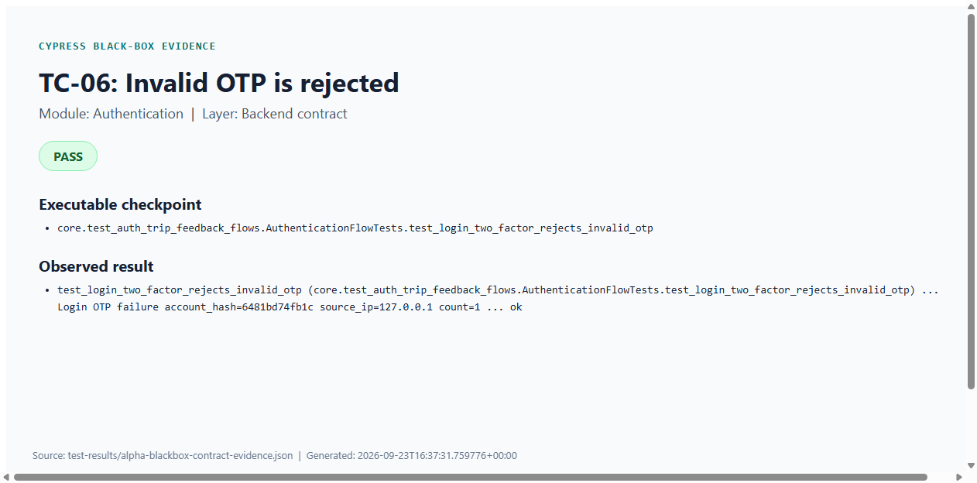
Figure C6: TC-06 — Invalid OTP is rejected (Cypress PASS evidence)

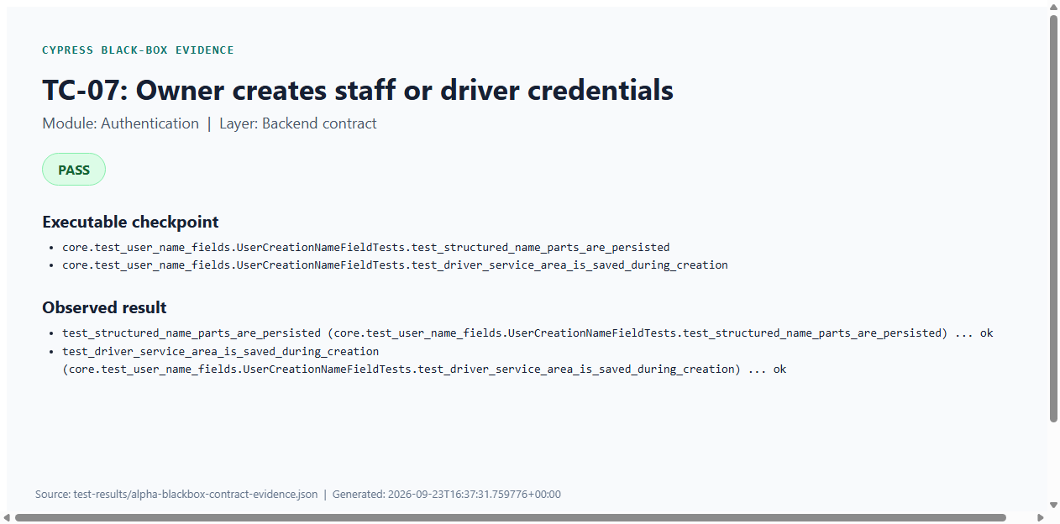
Figure C7: TC-07 — Owner creates staff or driver credentials (Cypress PASS evidence)
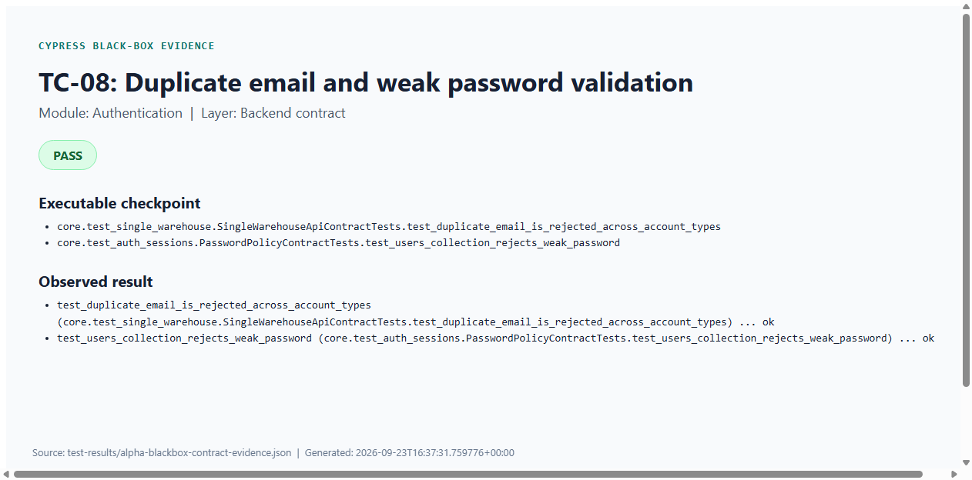
Figure C8: TC-08 — Duplicate email and weak password validation (Cypress PASS evidence)

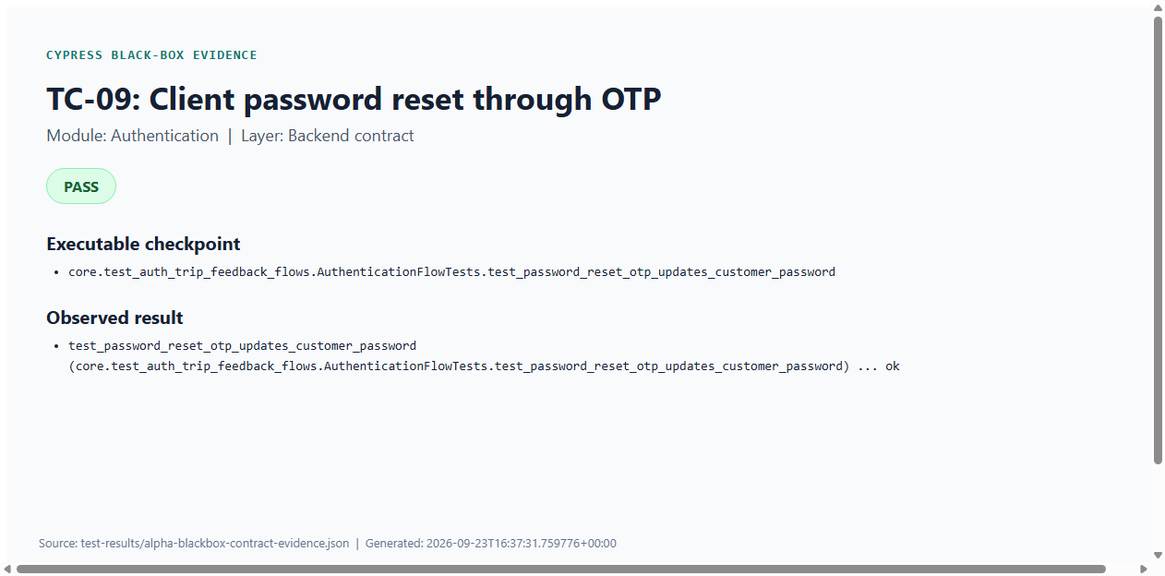
Figure C9: TC-09 — Client password reset through OTP (Cypress PASS evidence)
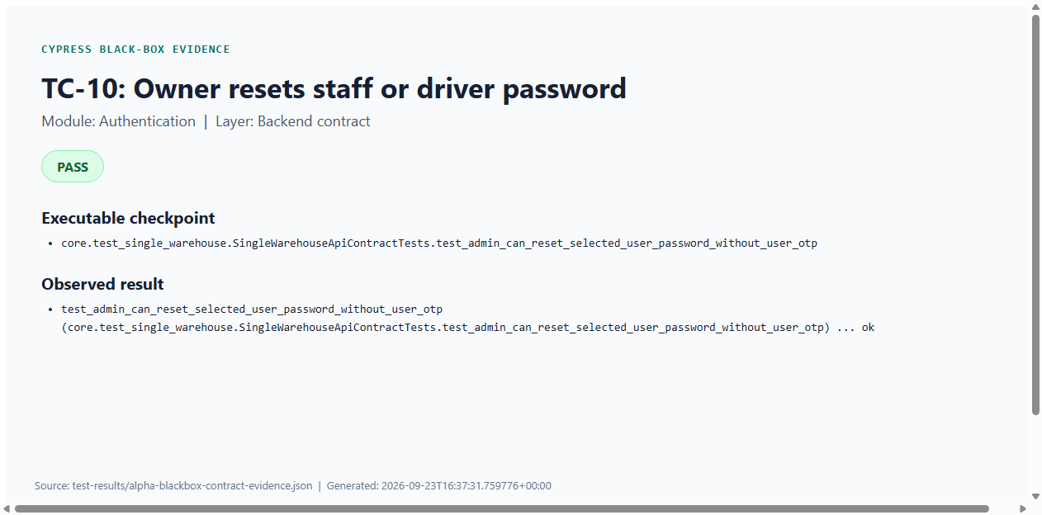
Figure C10: TC-10 — Owner resets staff or driver password (Cypress PASS evidence)

Cypress Evidence — Profile
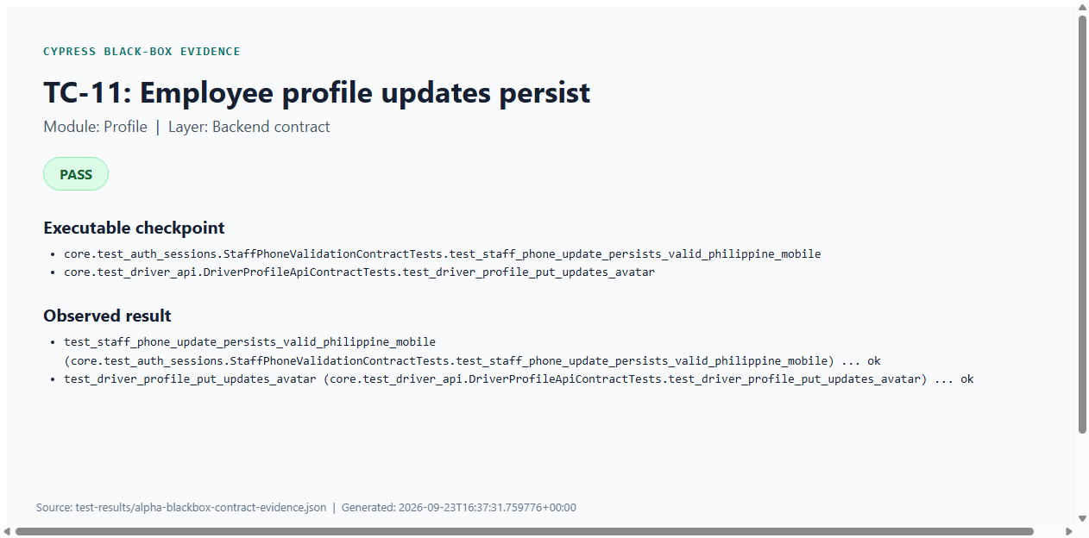
Figure C11: TC-11 — Employee profile updates persist (Cypress PASS evidence)
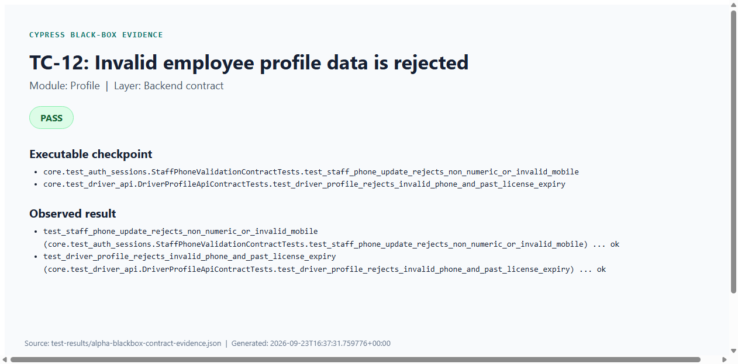
Figure C12: TC-12 — Invalid employee profile data is rejected (Cypress PASS evidence)

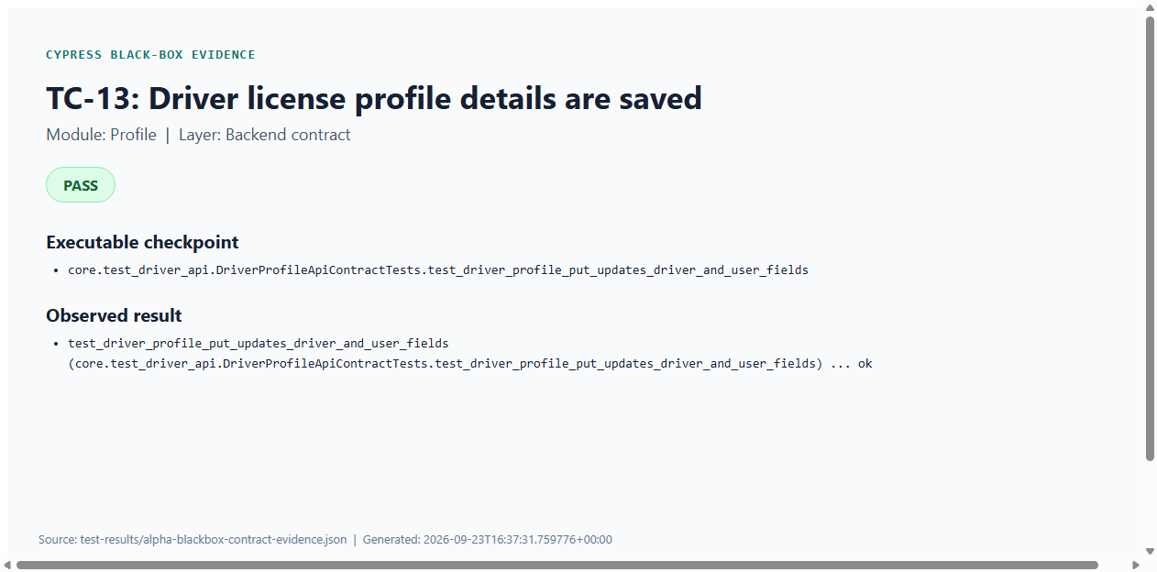
Figure C13: TC-13 — Driver license profile details are saved (Cypress PASS evidence)
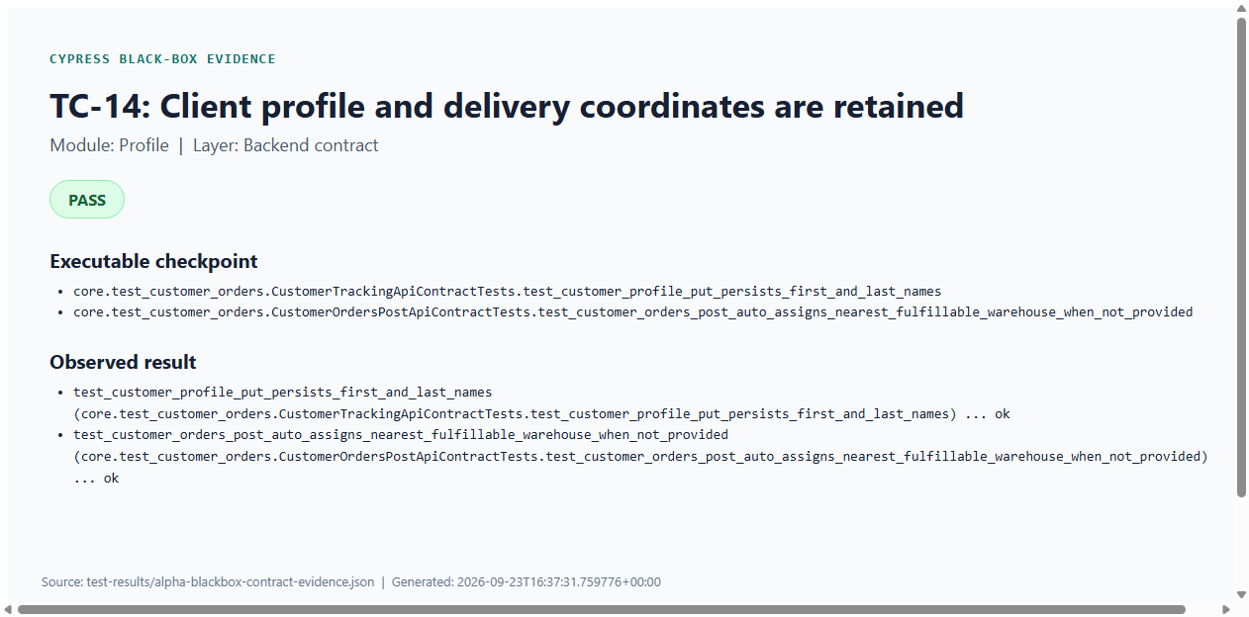
Figure C14: TC-14 — Client profile and delivery coordinates are retained (Cypress PASS evidence)

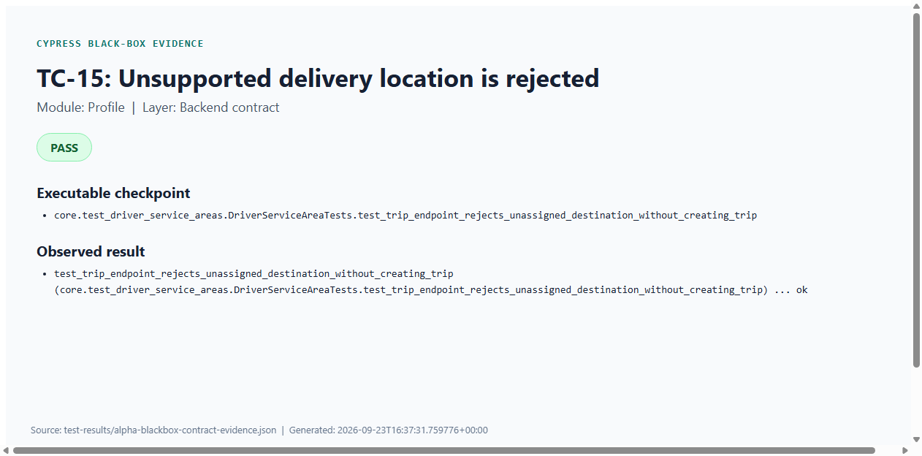
Figure C15: TC-15 — Unsupported delivery location is rejected (Cypress PASS evidence)

Cypress Evidence — Master Data
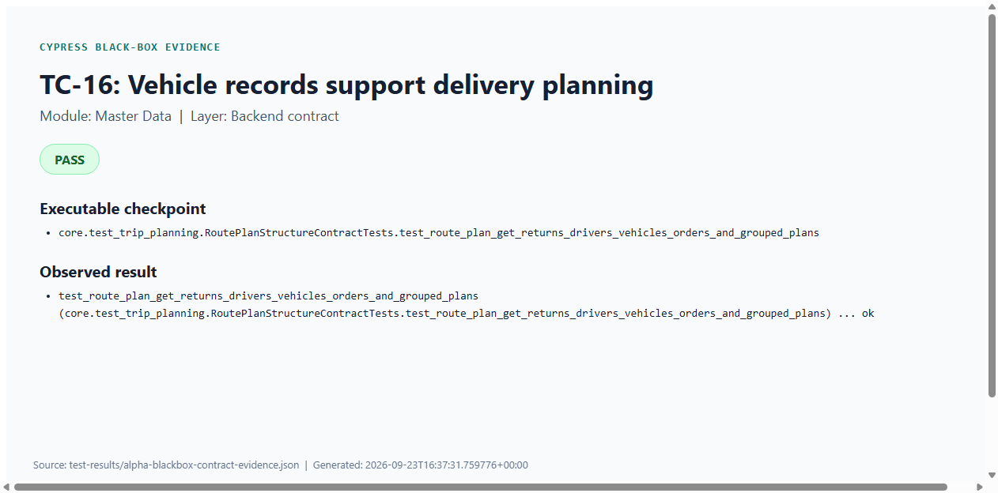
Figure C16: TC-16 — Vehicle records support delivery planning (Cypress PASS evidence)
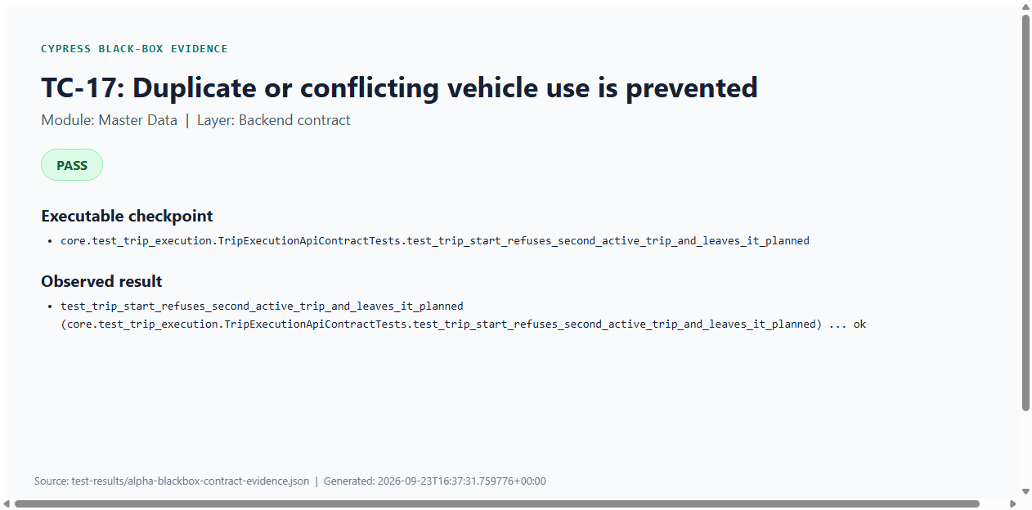
Figure C17: TC-17 — Duplicate or conflicting vehicle use is prevented (Cypress PASS evidence)

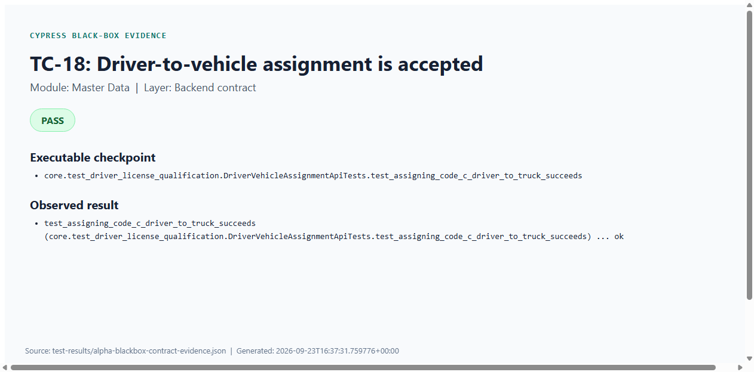
Figure C18: TC-18 — Driver-to-vehicle assignment is accepted (Cypress PASS evidence)
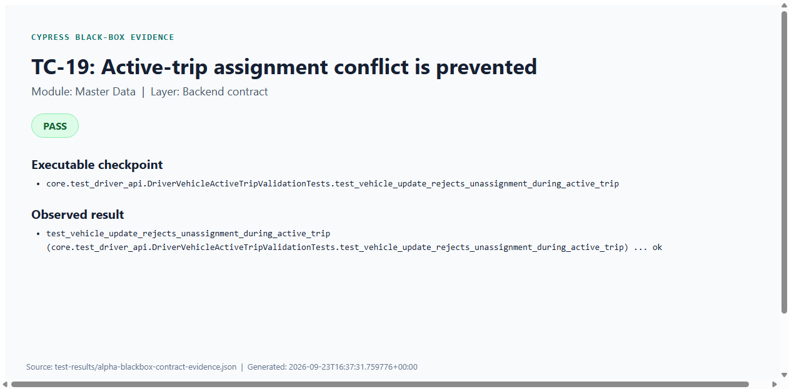
Figure C19: TC-19 — Active-trip assignment conflict is prevented (Cypress PASS evidence)

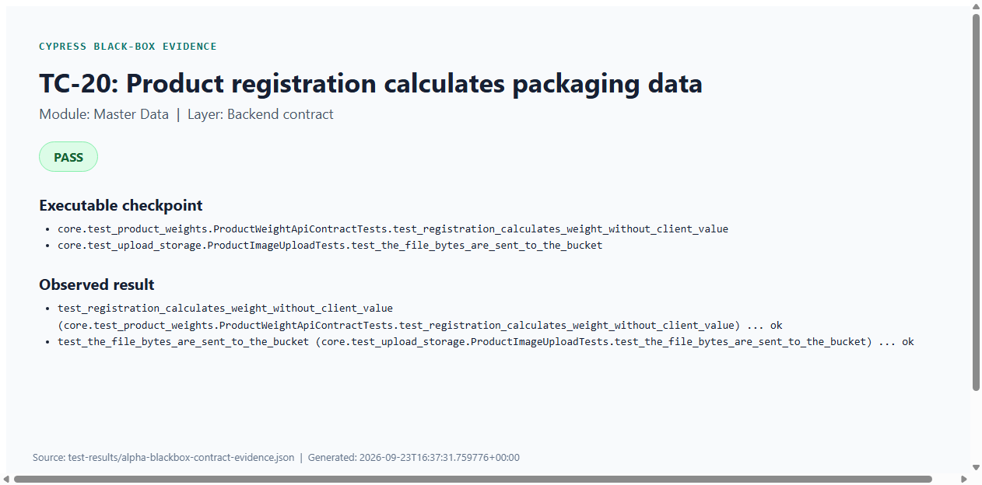
Figure C20: TC-20 — Product registration calculates packaging data (Cypress PASS evidence)
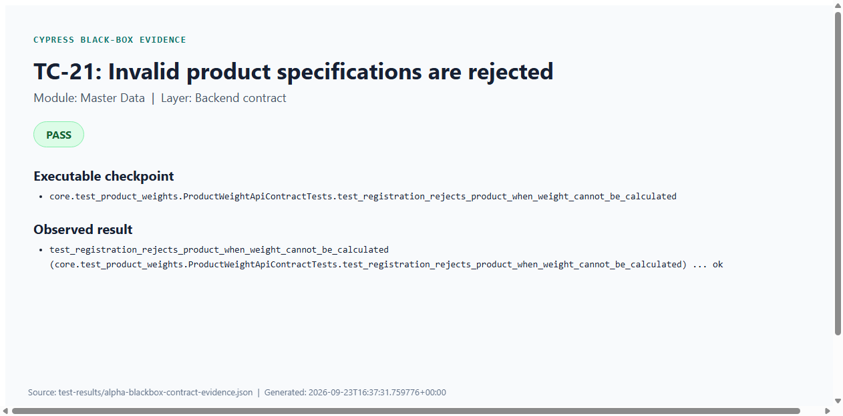
Figure C21: TC-21 — Invalid product specifications are rejected (Cypress PASS evidence)

Cypress Evidence — Inventory
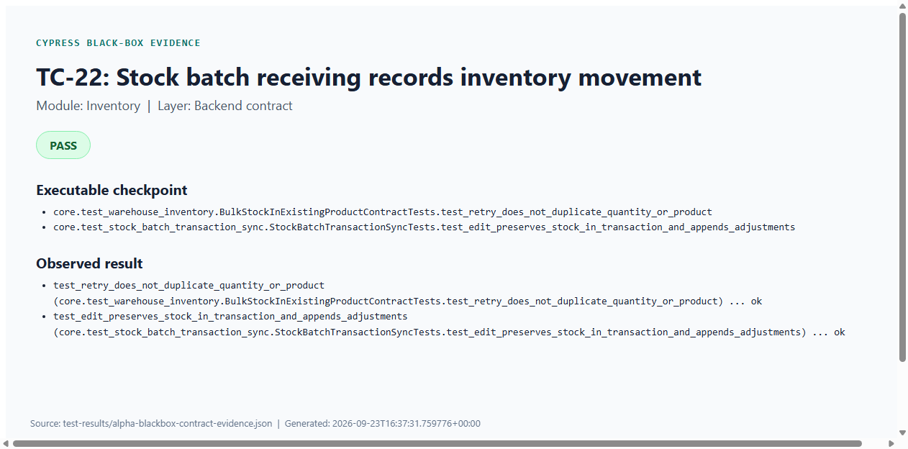
Figure C22: TC-22 — Stock batch receiving records inventory movement (Cypress PASS evidence)
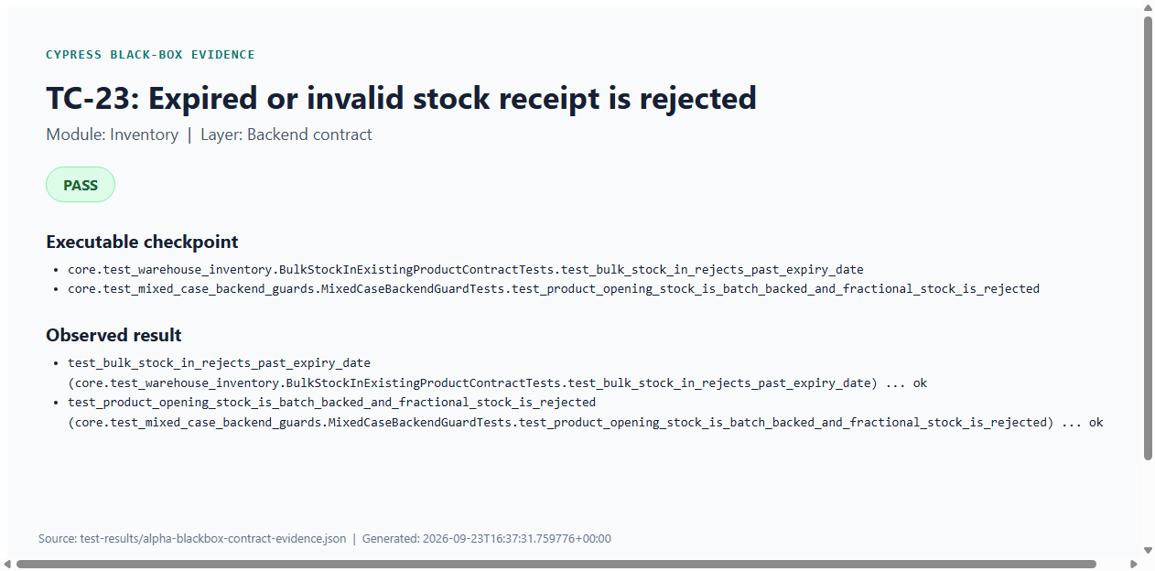
Figure C23: TC-23 — Expired or invalid stock receipt is rejected (Cypress PASS evidence)

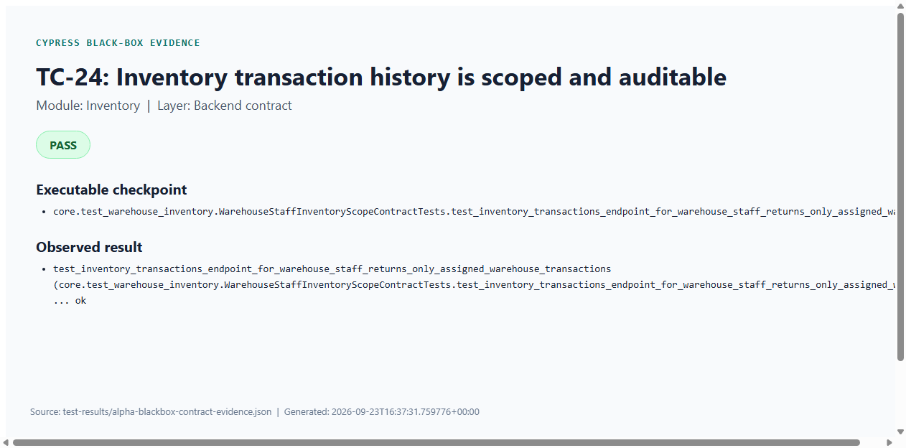
Figure C24: TC-24 — Inventory transaction history is scoped and auditable (Cypress PASS evidence)
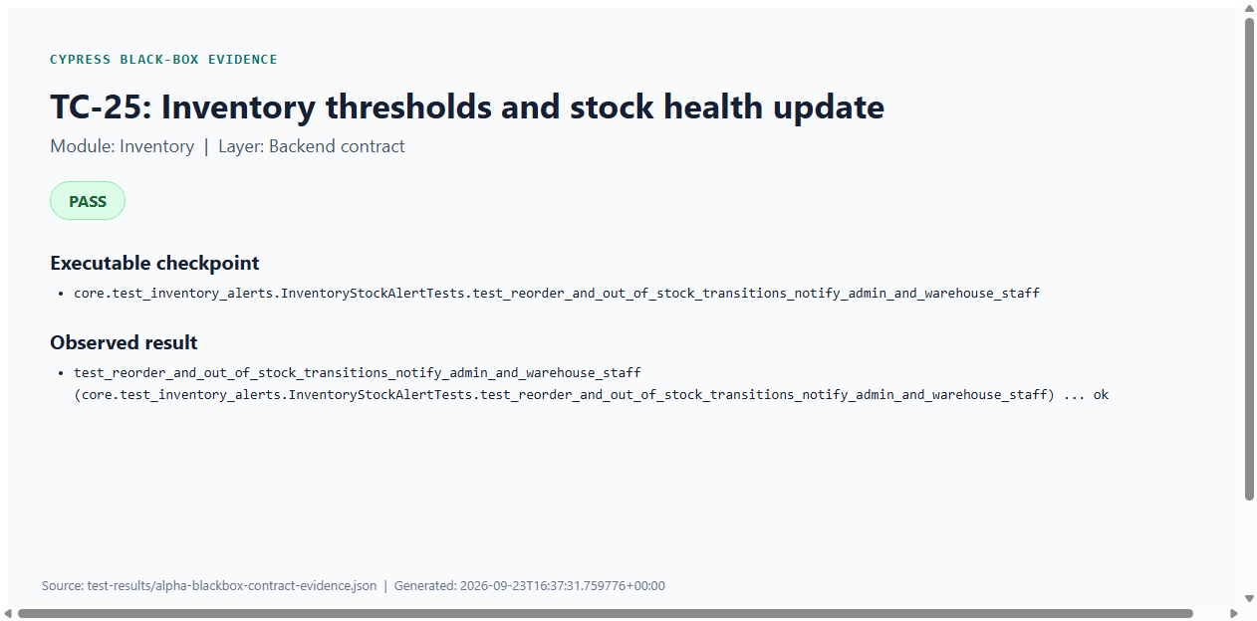
Figure C25: TC-25 — Inventory thresholds and stock health update (Cypress PASS evidence)

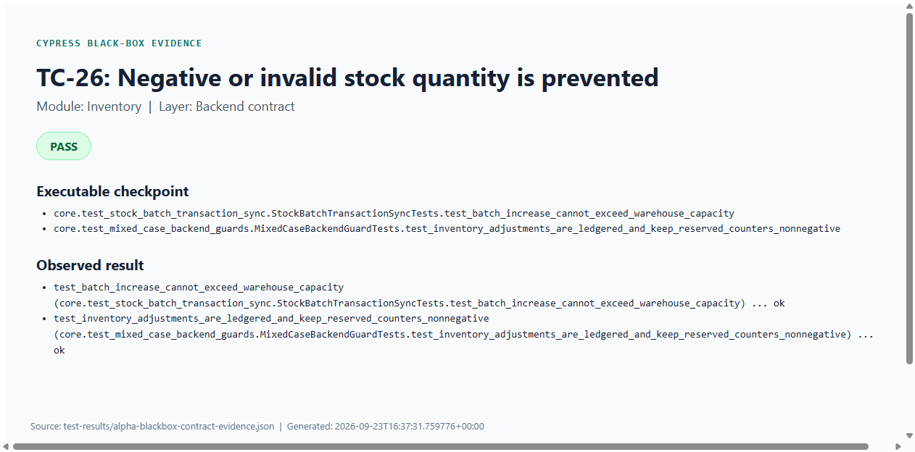
Figure C26: TC-26 — Negative or invalid stock quantity is prevented (Cypress PASS evidence)

Cypress Evidence — Orders
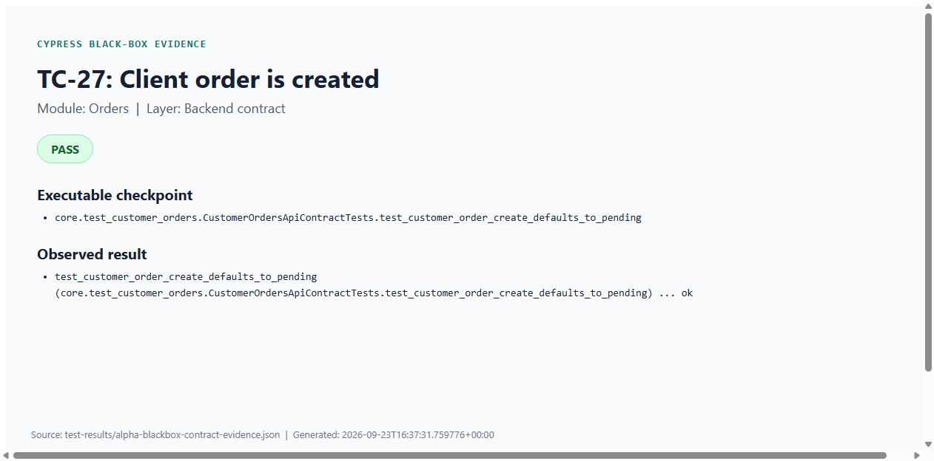
Figure C27: TC-27 — Client order is created (Cypress PASS evidence)
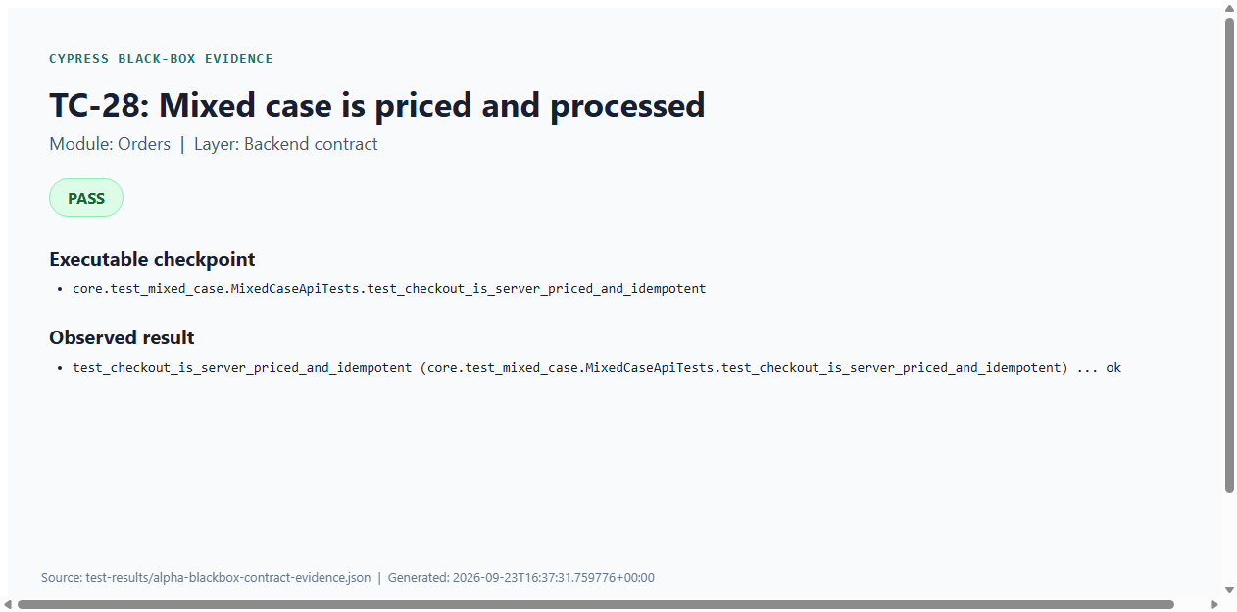
Figure C28: TC-28 — Mixed case is priced and processed (Cypress PASS evidence)

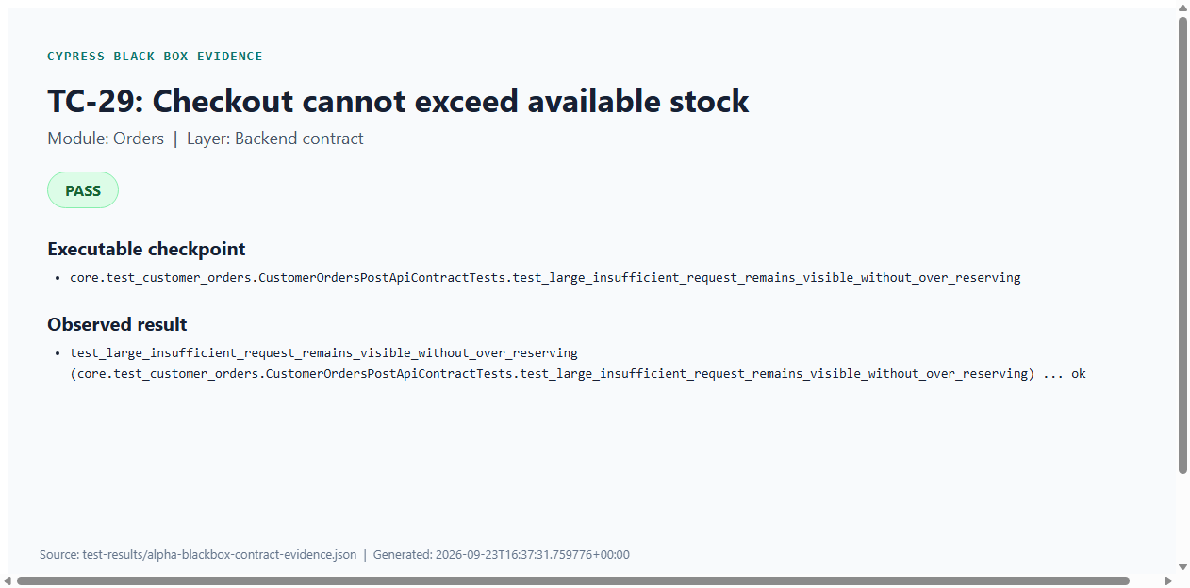
Figure C29: TC-29 — Checkout cannot exceed available stock (Cypress PASS evidence)
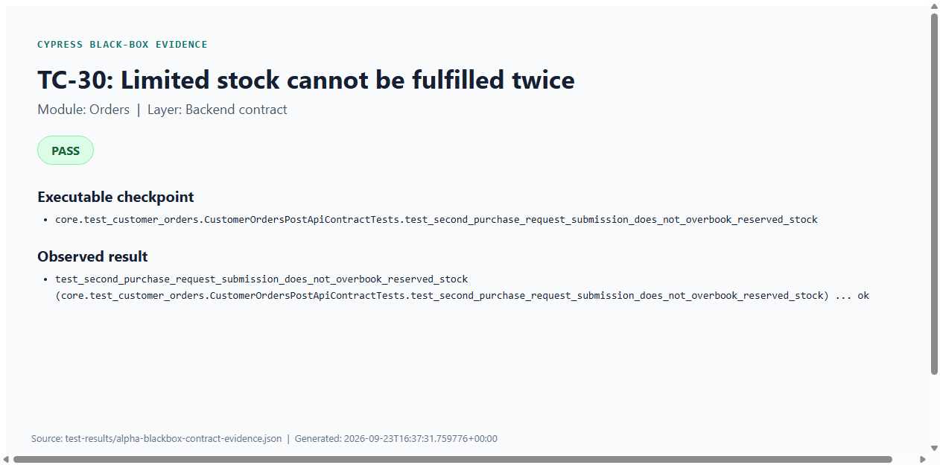
Figure C30: TC-30 — Limited stock cannot be fulfilled twice (Cypress PASS evidence)

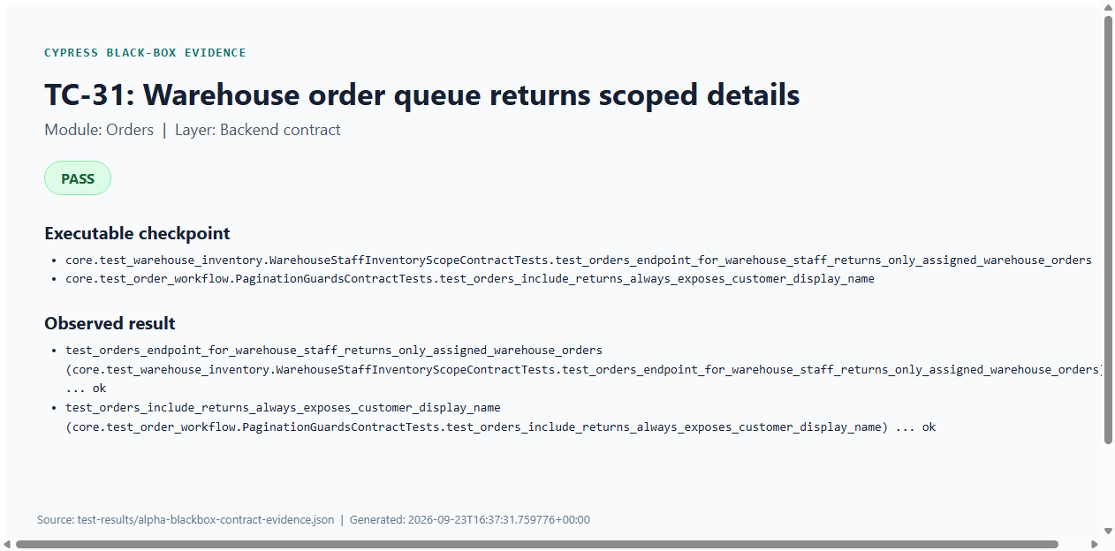
Figure C31: TC-31 — Warehouse order queue returns scoped details (Cypress PASS evidence)
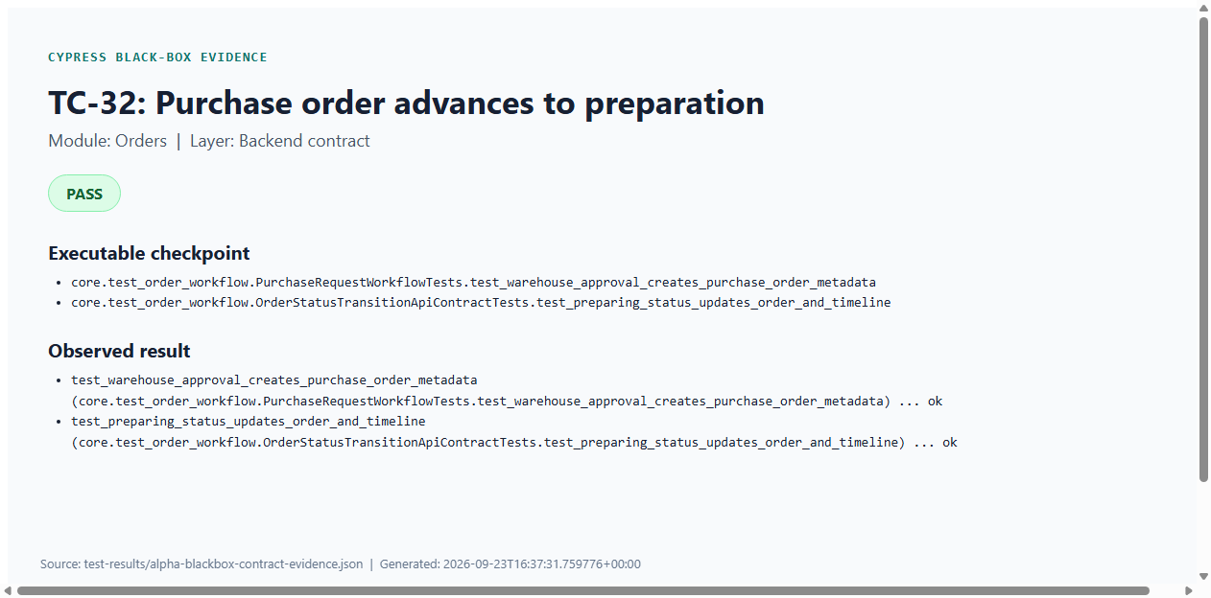
Figure C32: TC-32 — Purchase order advances to preparation (Cypress PASS evidence)

Cypress Evidence — Transportation
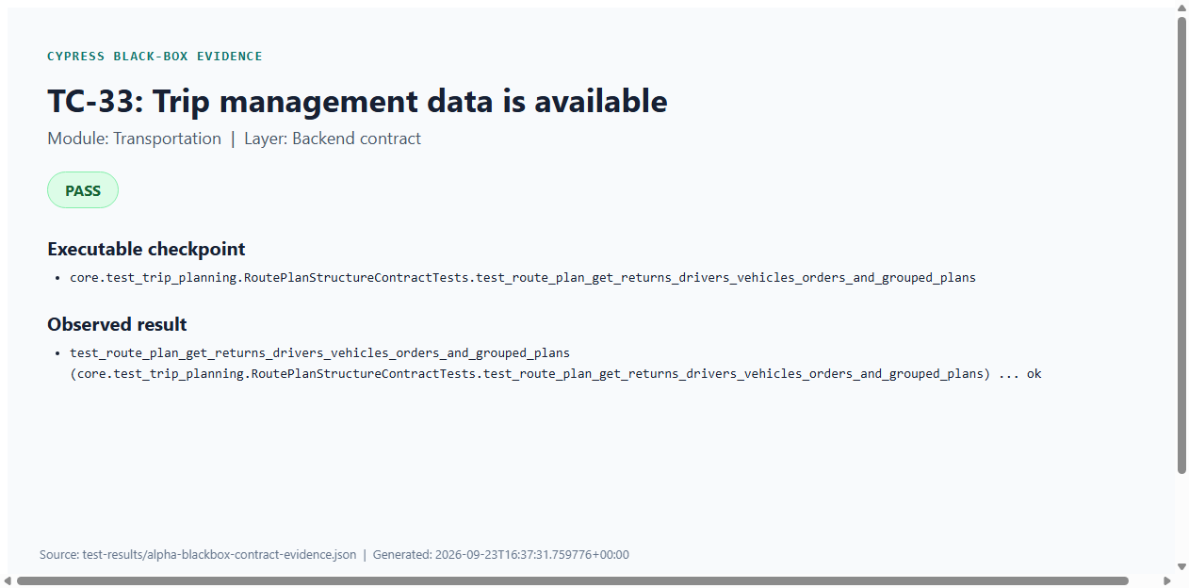
Figure C33: TC-33 — Trip management data is available (Cypress PASS evidence)
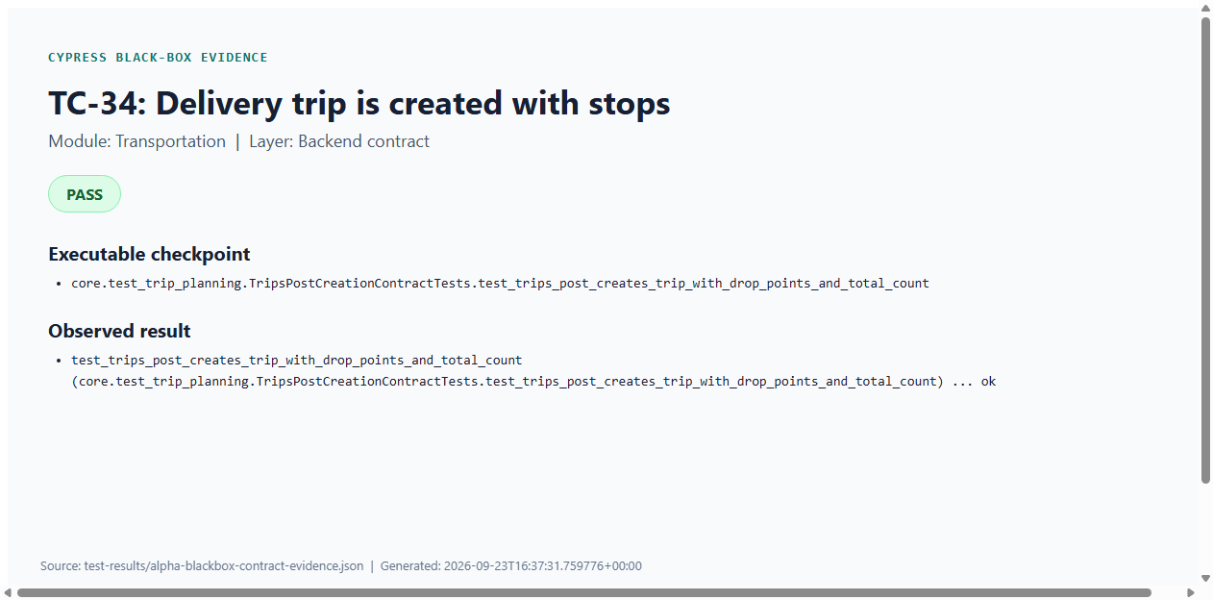
Figure C34: TC-34 — Delivery trip is created with stops (Cypress PASS evidence)

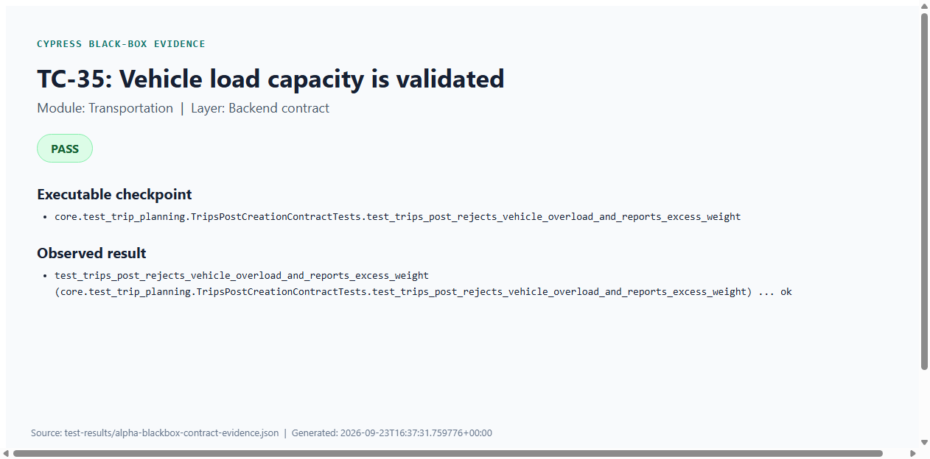
Figure C35: TC-35 — Vehicle load capacity is validated (Cypress PASS evidence)
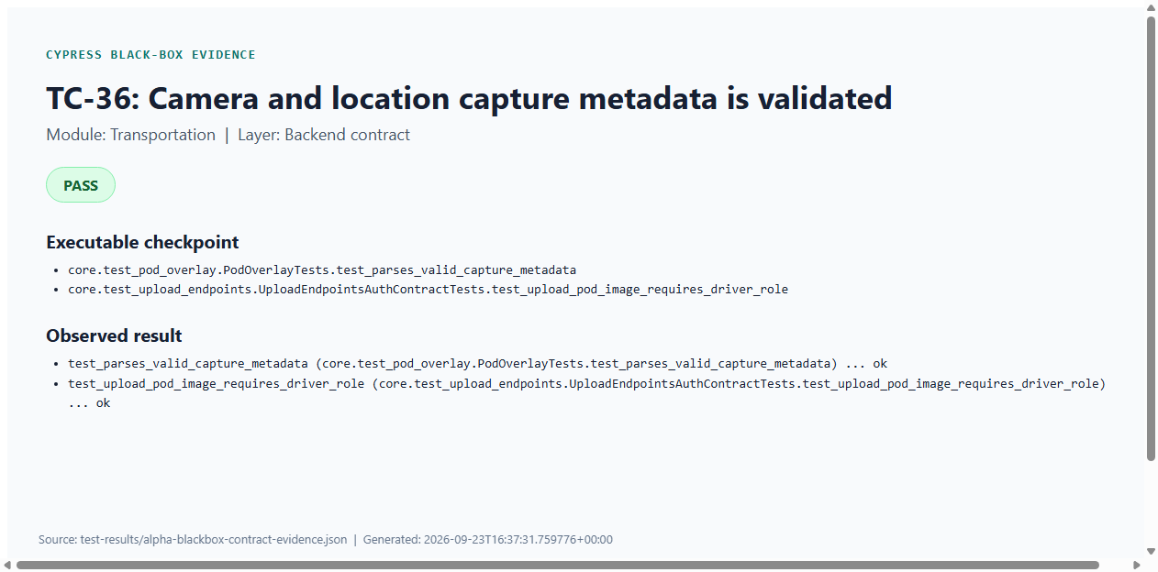
Figure C36: TC-36 — Camera and location capture metadata is validated (Cypress PASS evidence)

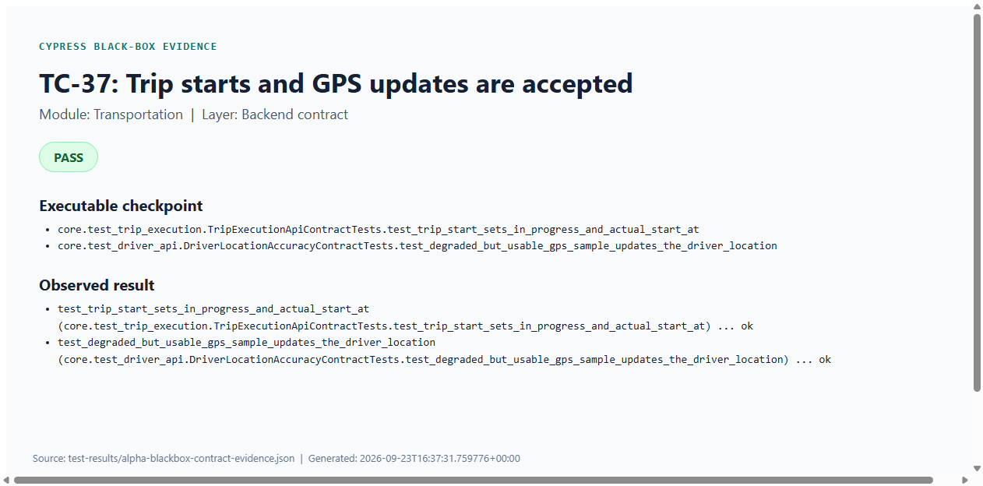
Figure C37: TC-37 — Trip starts and GPS updates are accepted (Cypress PASS evidence)
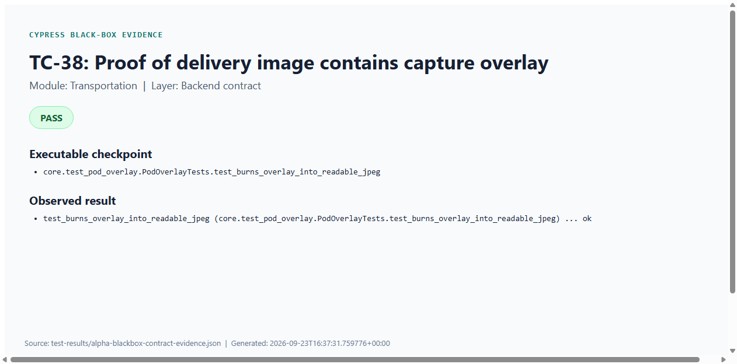
Figure C38: TC-38 — Proof of delivery image contains capture overlay (Cypress PASS evidence)

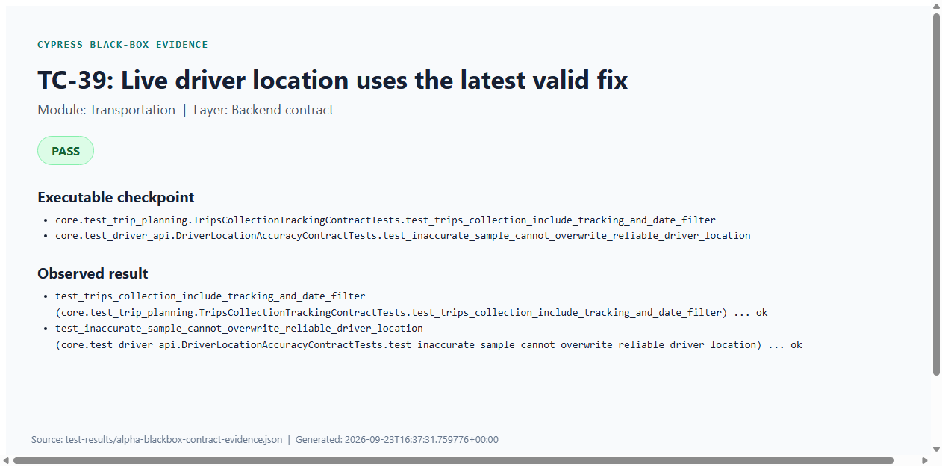
Figure C39: TC-39 — Live driver location uses the latest valid fix (Cypress PASS evidence)
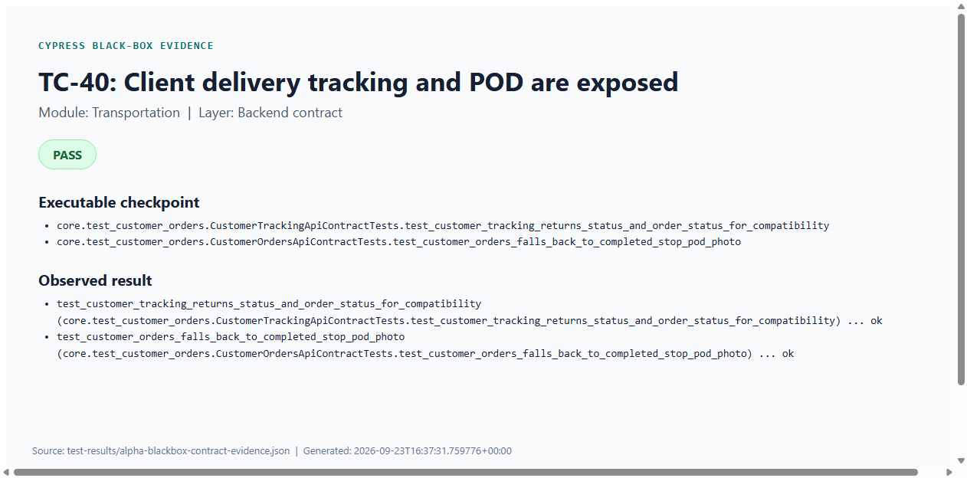
Figure C40: TC-40 — Client delivery tracking and POD are exposed (Cypress PASS evidence)

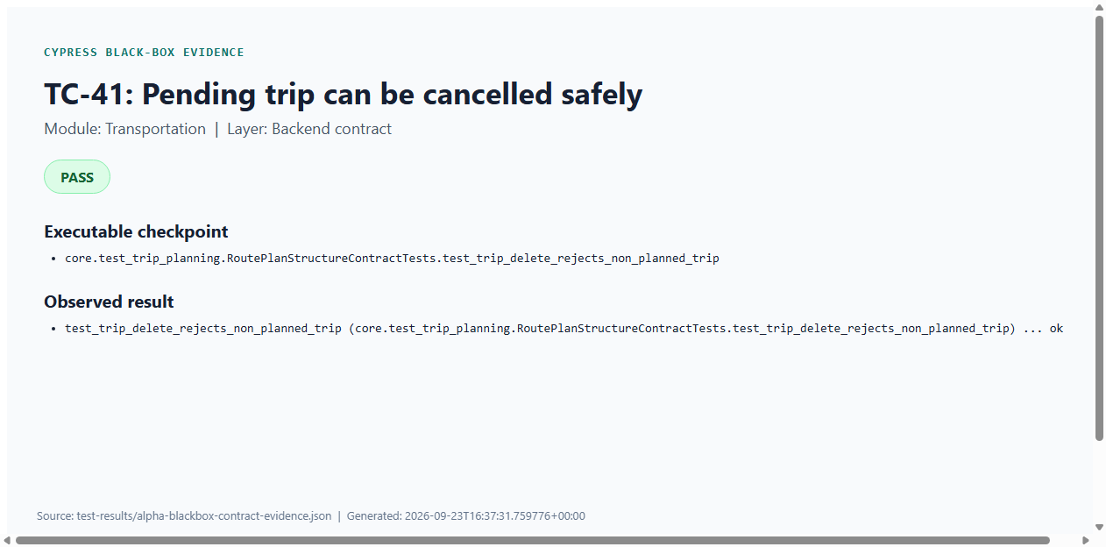
Figure C41: TC-41 — Pending trip can be cancelled safely (Cypress PASS evidence)

Cypress Evidence — Replacements
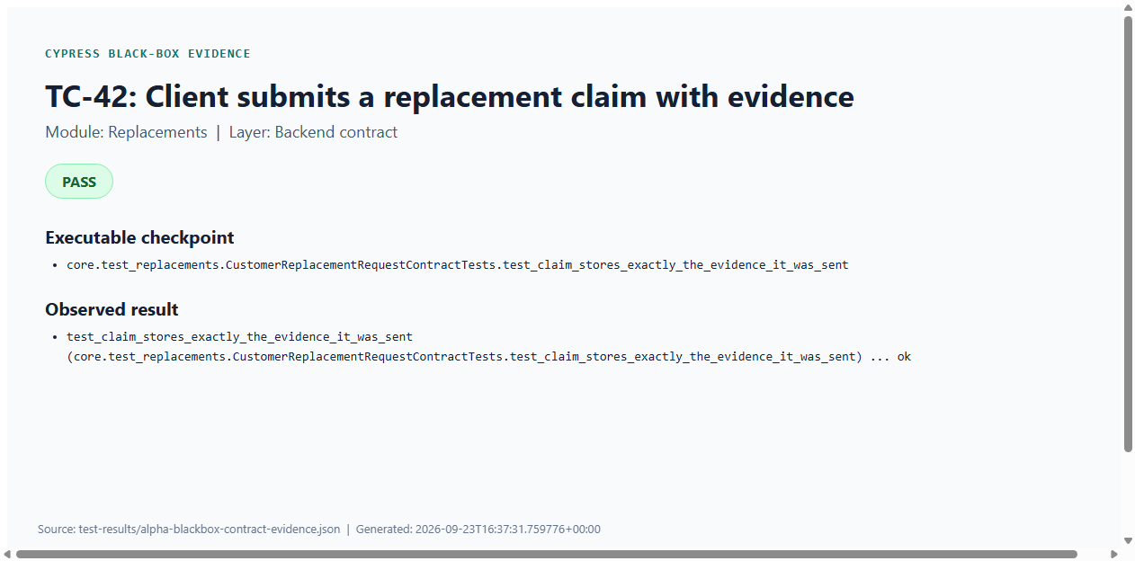
Figure C42: TC-42 — Client submits a replacement claim with evidence (Cypress PASS evidence)
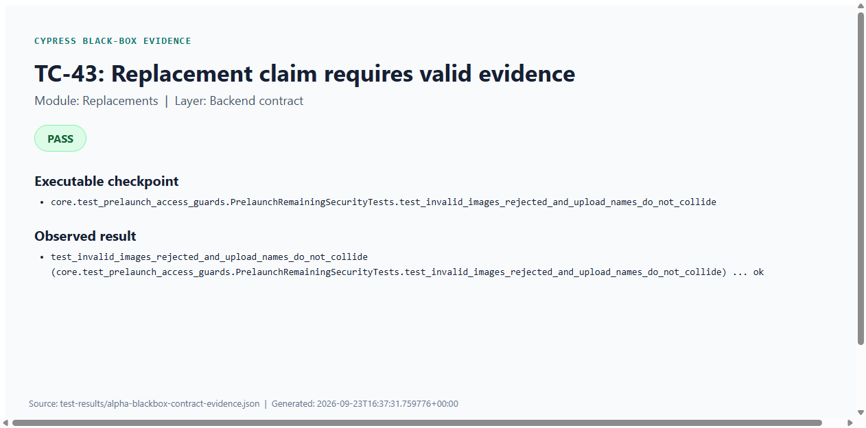
Figure C43: TC-43 — Replacement claim requires valid evidence (Cypress PASS evidence)

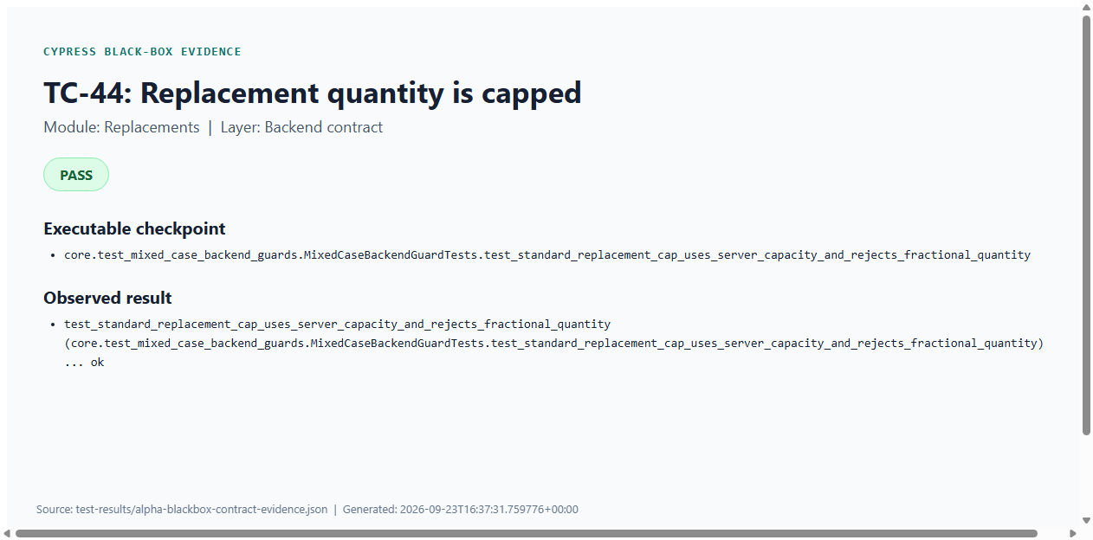
Figure C44: TC-44 — Replacement quantity is capped (Cypress PASS evidence)
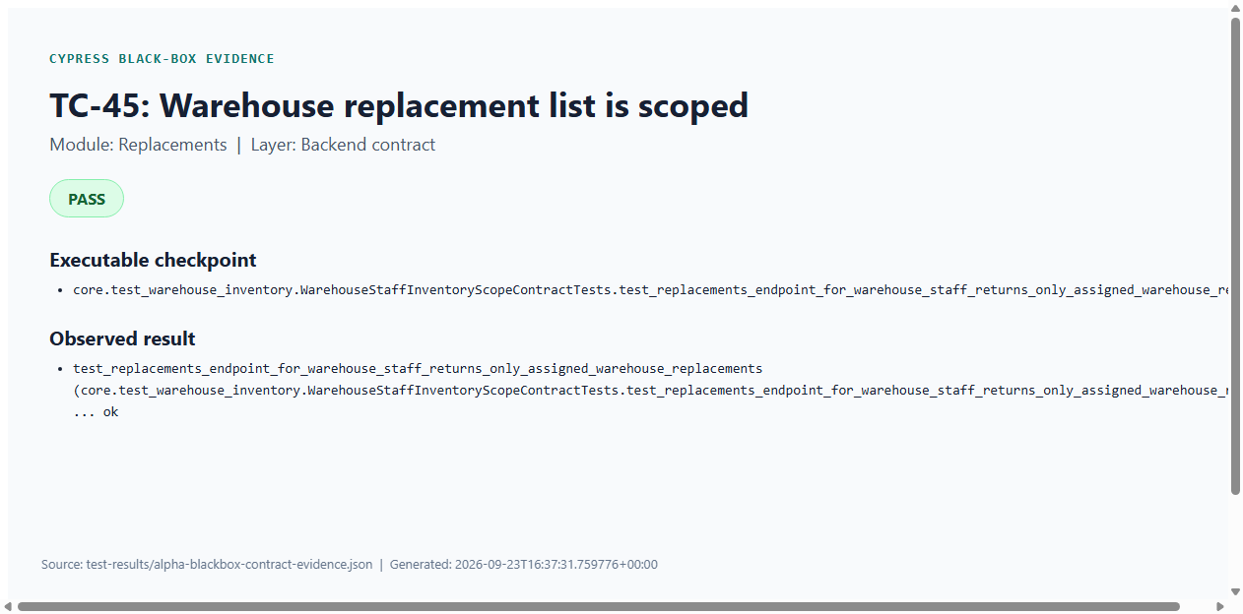
Figure C45: TC-45 — Warehouse replacement list is scoped (Cypress PASS evidence)

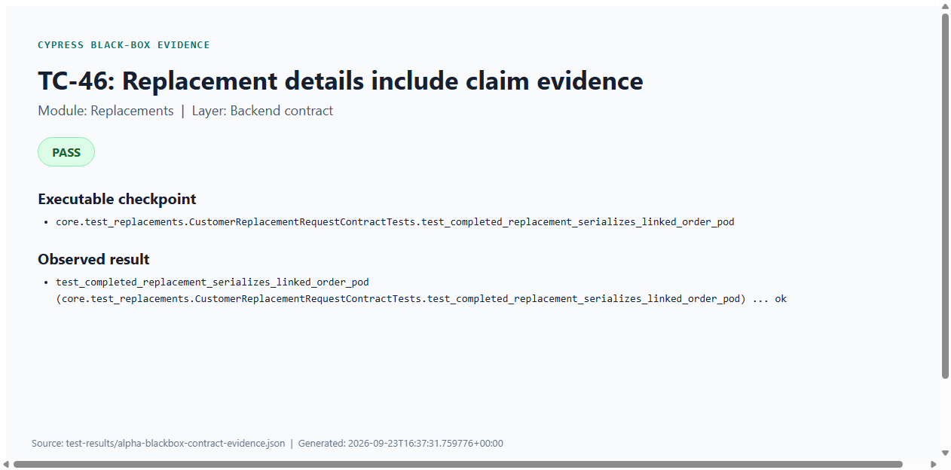
Figure C46: TC-46 — Replacement details include claim evidence (Cypress PASS evidence)
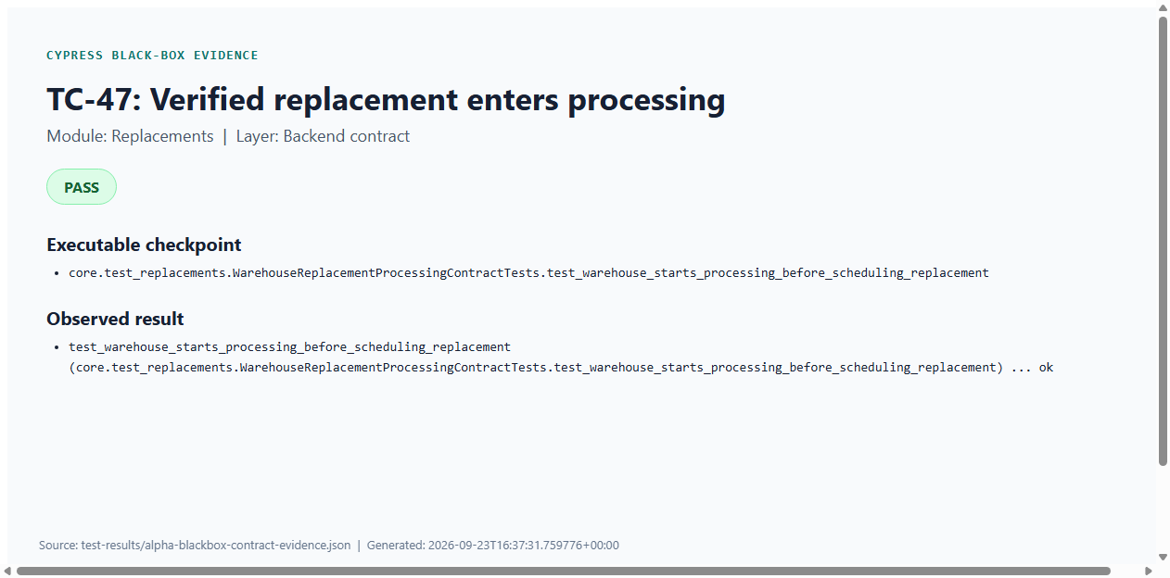
Figure C47: TC-47 — Verified replacement enters processing (Cypress PASS evidence)

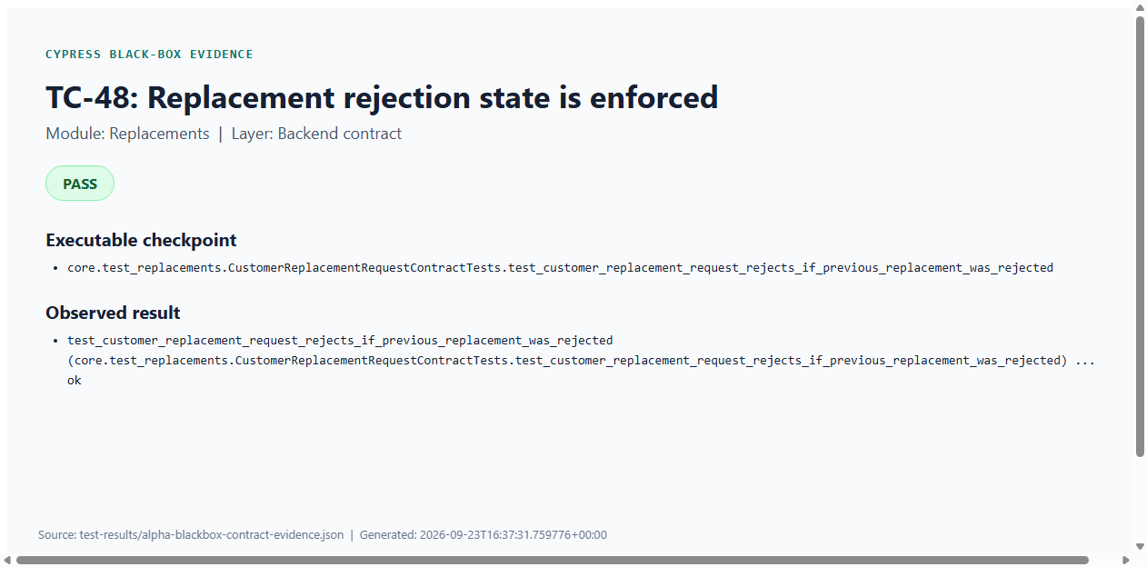
Figure C48: TC-48 — Replacement rejection state is enforced (Cypress PASS evidence)
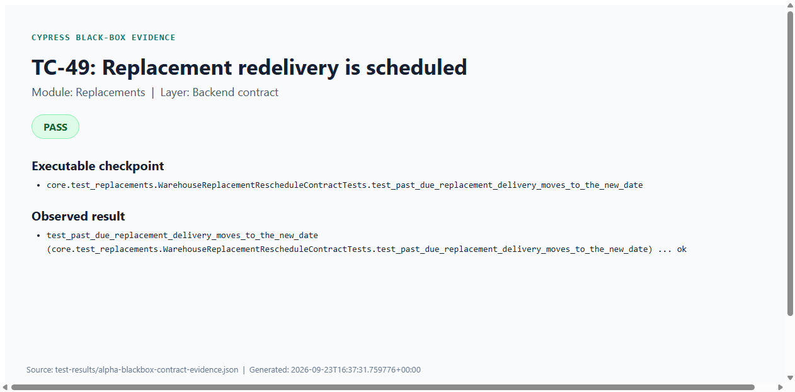
Figure C49: TC-49 — Replacement redelivery is scheduled (Cypress PASS evidence)

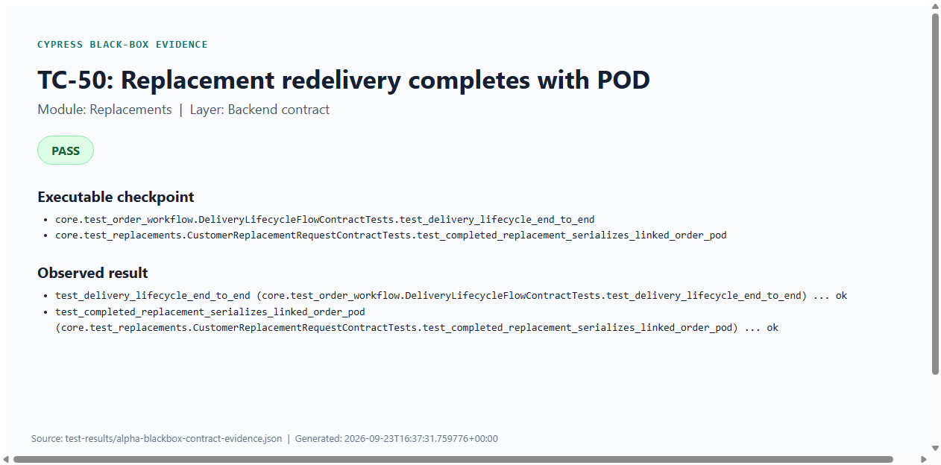
Figure C50: TC-50 — Replacement redelivery completes with POD (Cypress PASS evidence)

Cypress Evidence — Feedback
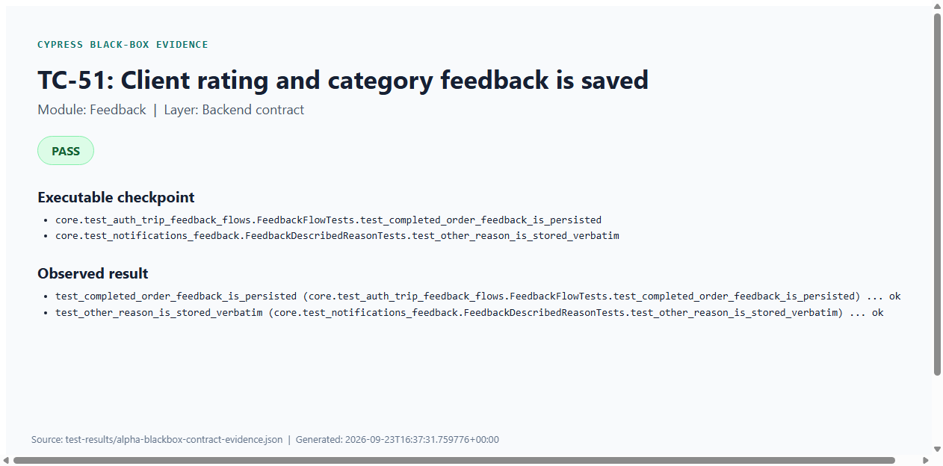
Figure C51: TC-51 — Client rating and category feedback is saved (Cypress PASS evidence)
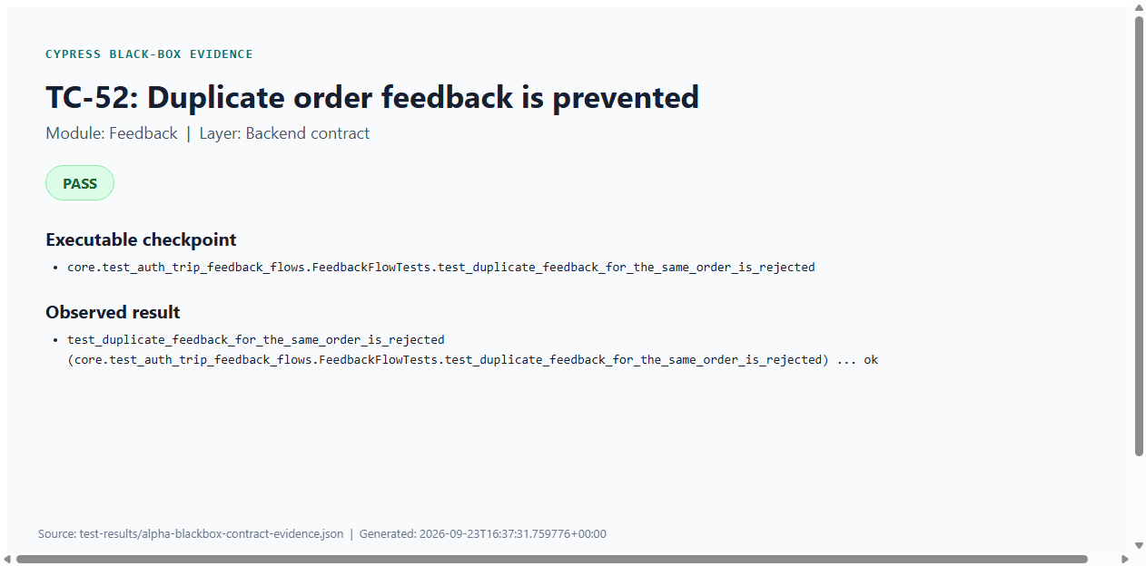
Figure C52: TC-52 — Duplicate order feedback is prevented (Cypress PASS evidence)

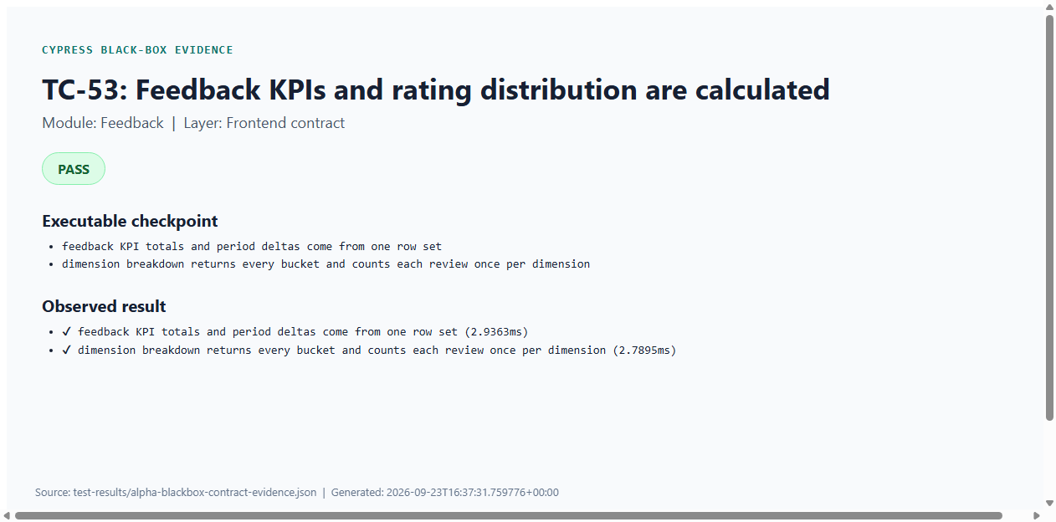
Figure C53: TC-53 — Feedback KPIs and rating distribution are calculated (Cypress PASS evidence)
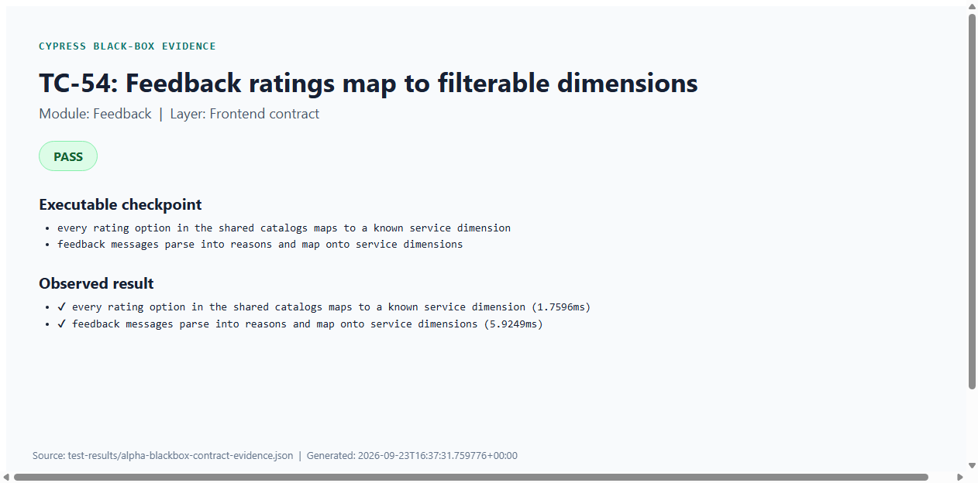
Figure C54: TC-54 — Feedback ratings map to filterable dimensions (Cypress PASS evidence)

Cypress Evidence — Reports
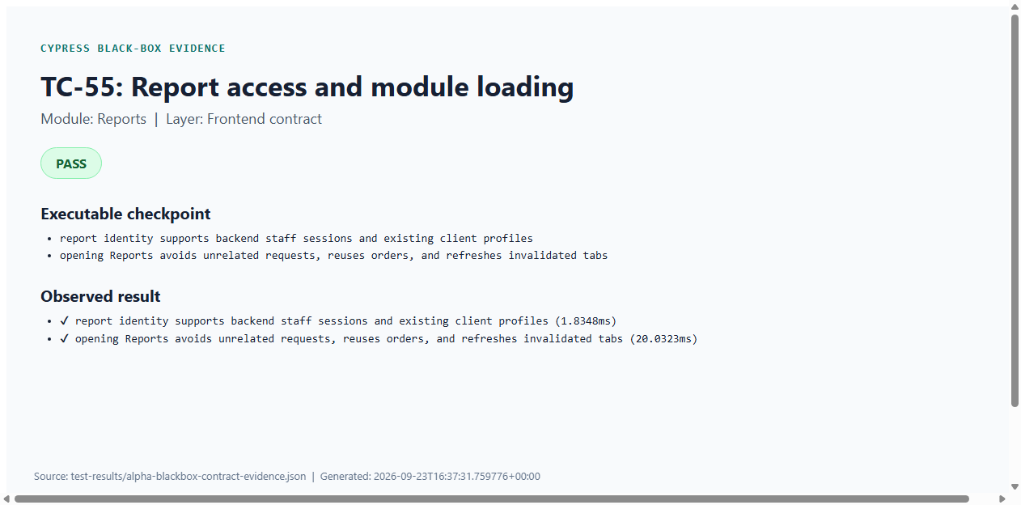
Figure C55: TC-55 — Report access and module loading (Cypress PASS evidence)
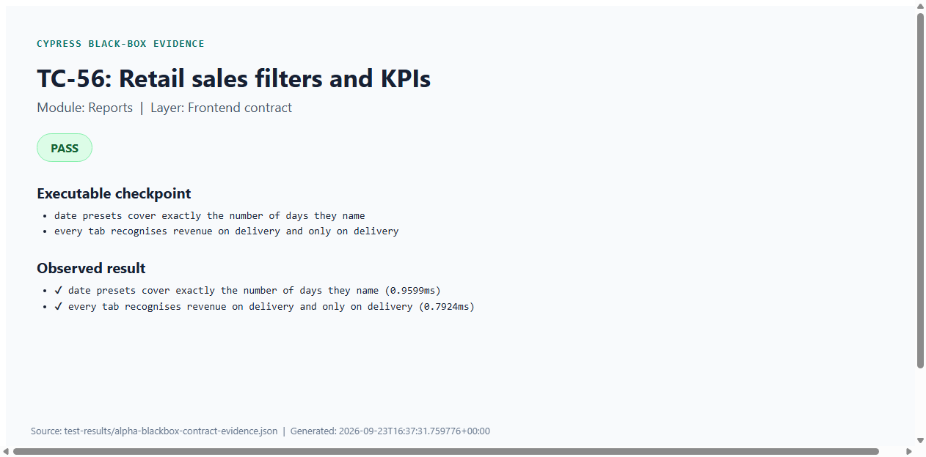
Figure C56: TC-56 — Retail sales filters and KPIs (Cypress PASS evidence)

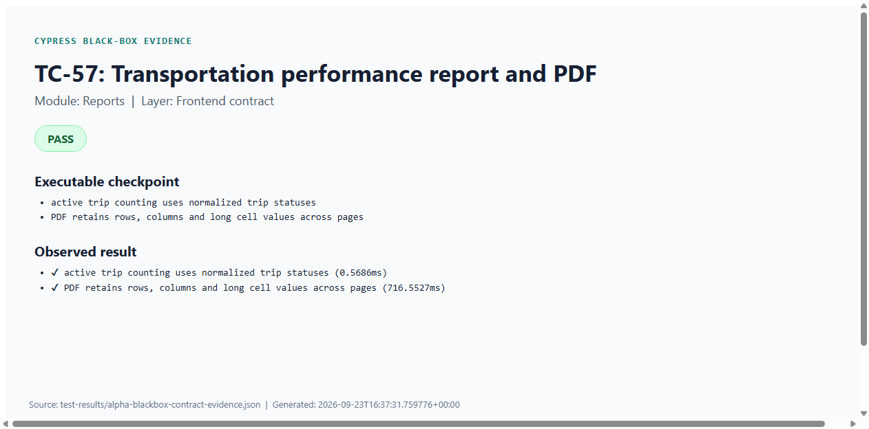
Figure C57: TC-57 — Transportation performance report and PDF (Cypress PASS evidence)
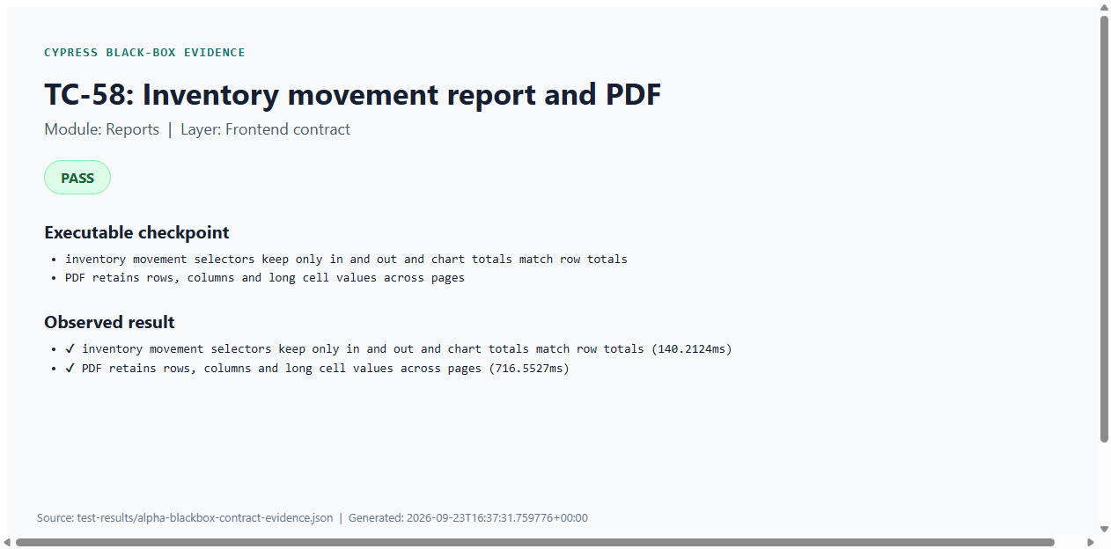
Figure C58: TC-58 — Inventory movement report and PDF (Cypress PASS evidence)

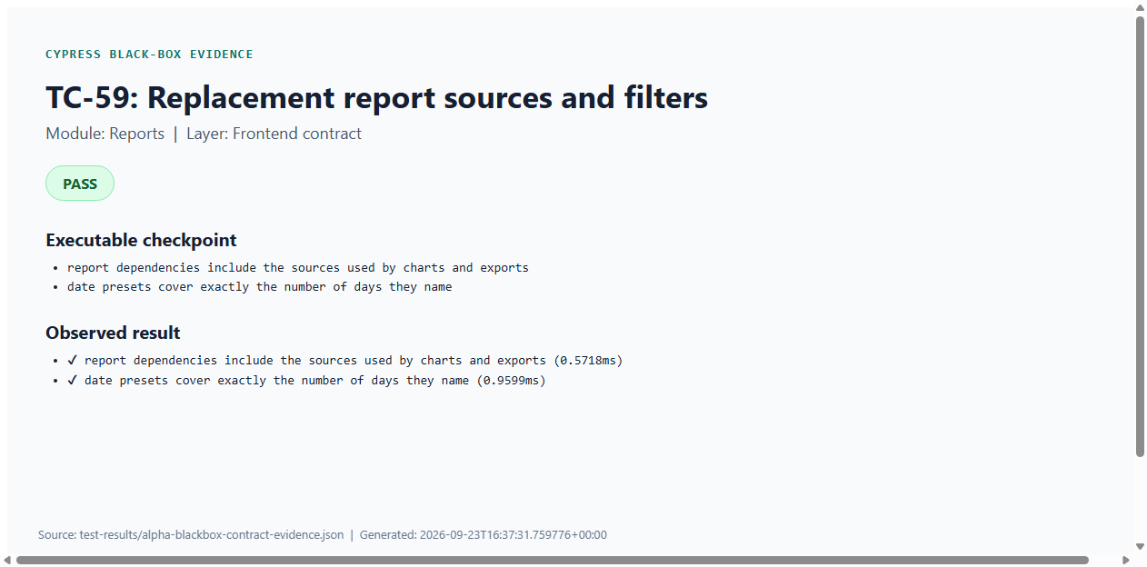
Figure C59: TC-59 — Replacement report sources and filters (Cypress PASS evidence)
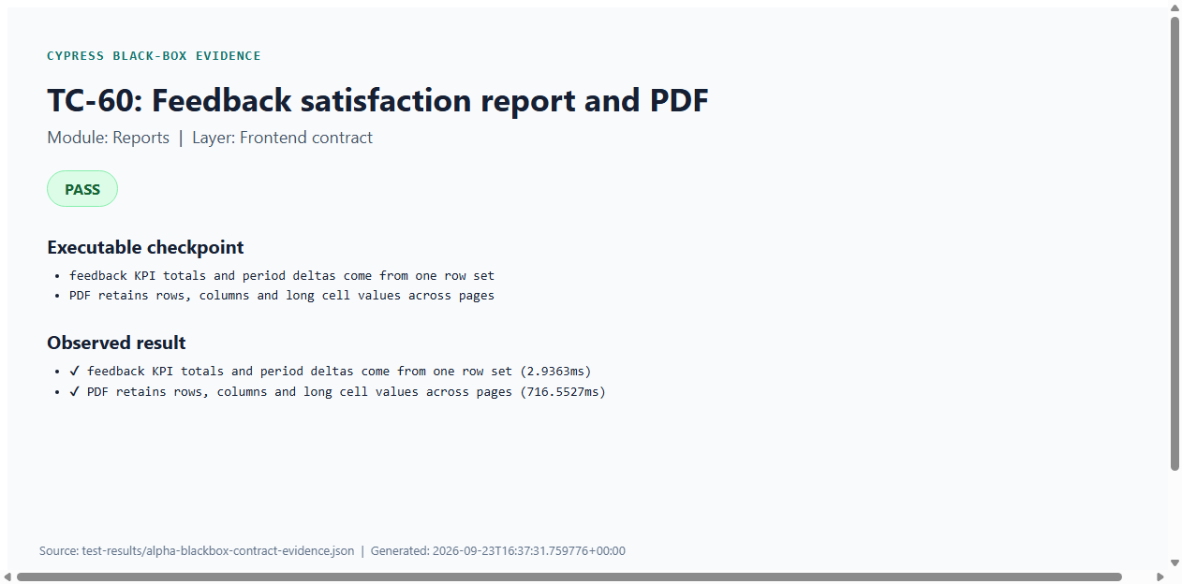
Figure C60: TC-60 — Feedback satisfaction report and PDF (Cypress PASS evidence)

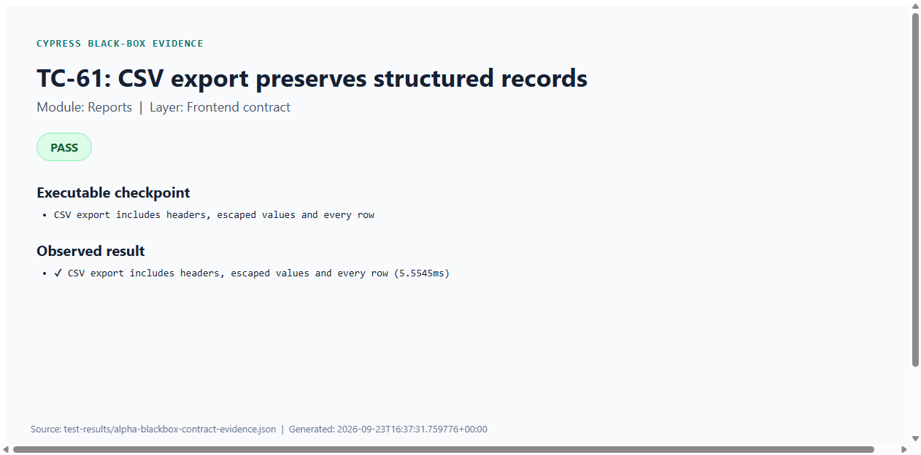
Figure C61: TC-61 — CSV export preserves structured records (Cypress PASS evidence)
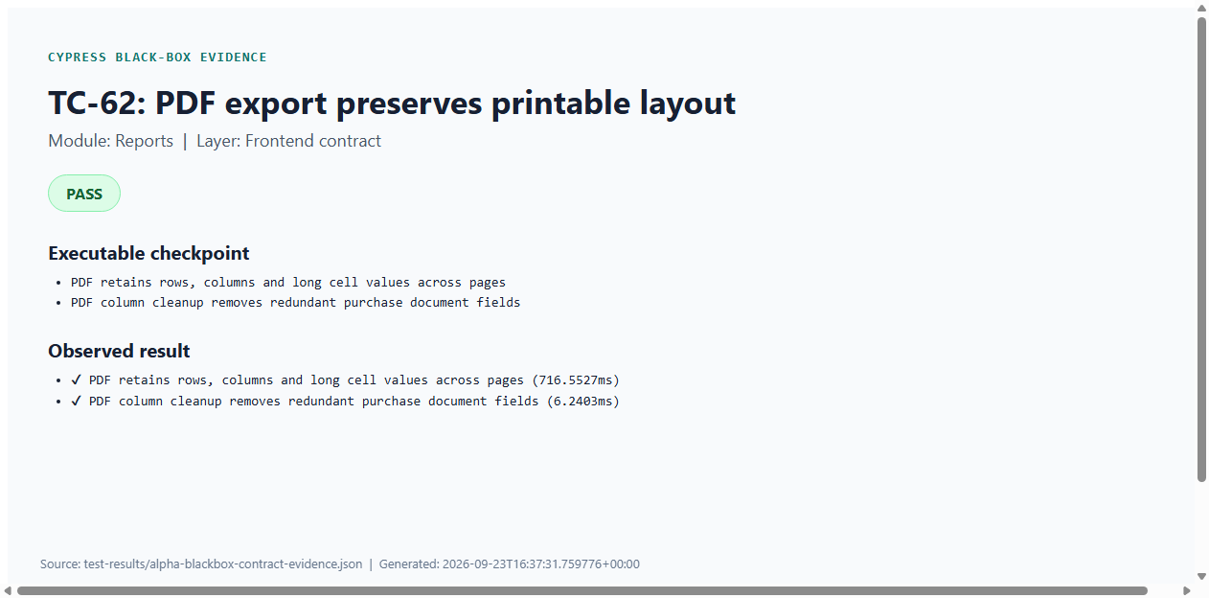
Figure C62: TC-62 — PDF export preserves printable layout (Cypress PASS evidence)

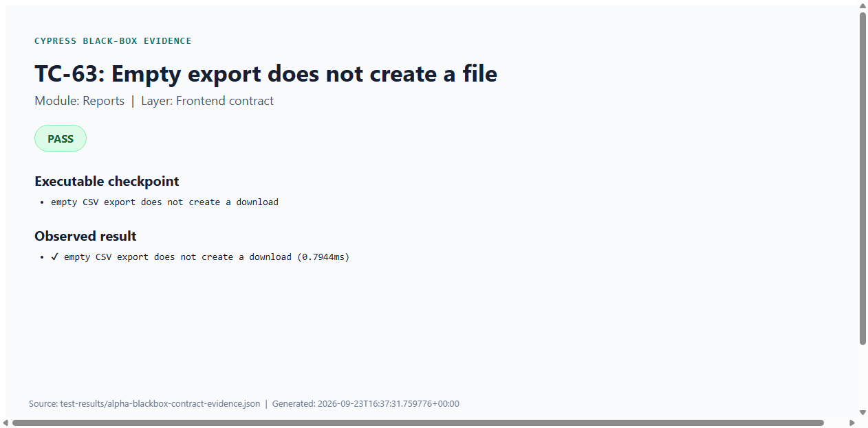
Figure C63: TC-63 — Empty export does not create a file (Cypress PASS evidence)

